Cli

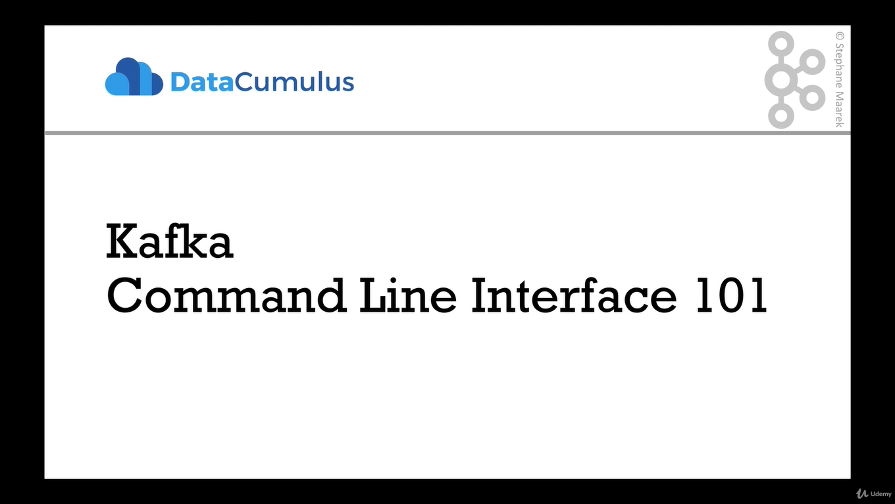

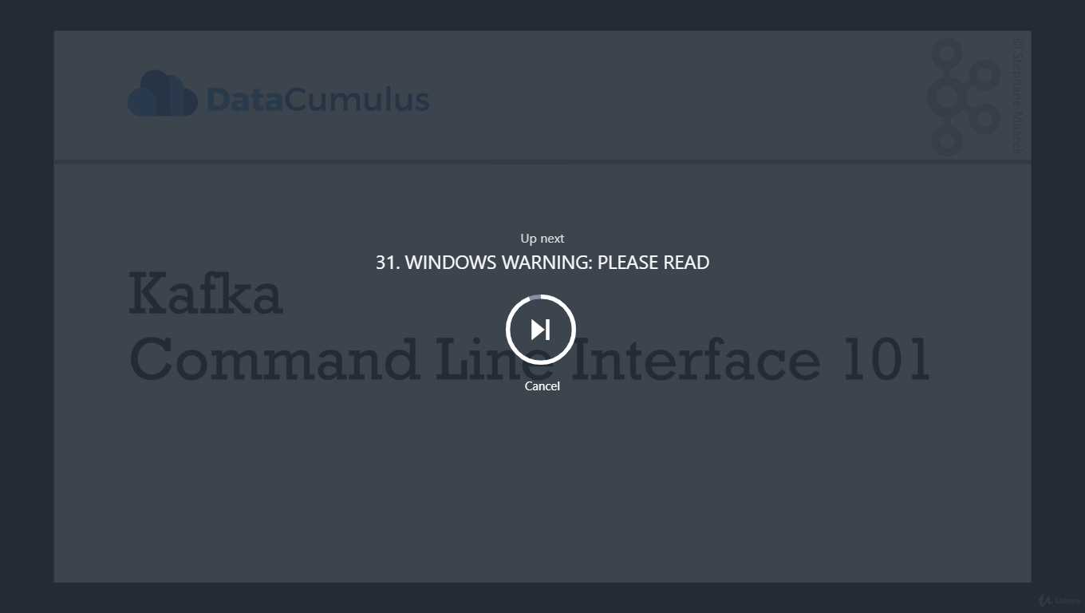

WINDOWS WARNING: PLEASE READ

**WINDOWS USERS PLEASE READ**

**In the next lecture, do not run the command to DELETE topics**

Because of a bug here: <https://issues.apache.org/jira/browse/KAFKA-1194>, it doesn't work. I'm actively working with the Kafka Dev team to see if I can get this fixed.

**In the meantime, please do not delete topics. Otherwise your Kafka will crash and you won't be able to do the tutorial.**

**A workaround is to launch Kafka inside of a Linux VM and do the tutorial from there.**

Thanks

Fullscreen

Go to Previous lecture

30. CLI Introduction

Go to Next lecture

32. Kafka Topics CLI

**Makesure Zookeeper and kafka is started**

**We’ll start with kafka-topic command , the extension can be .sh,.bat or nothing (brew)**

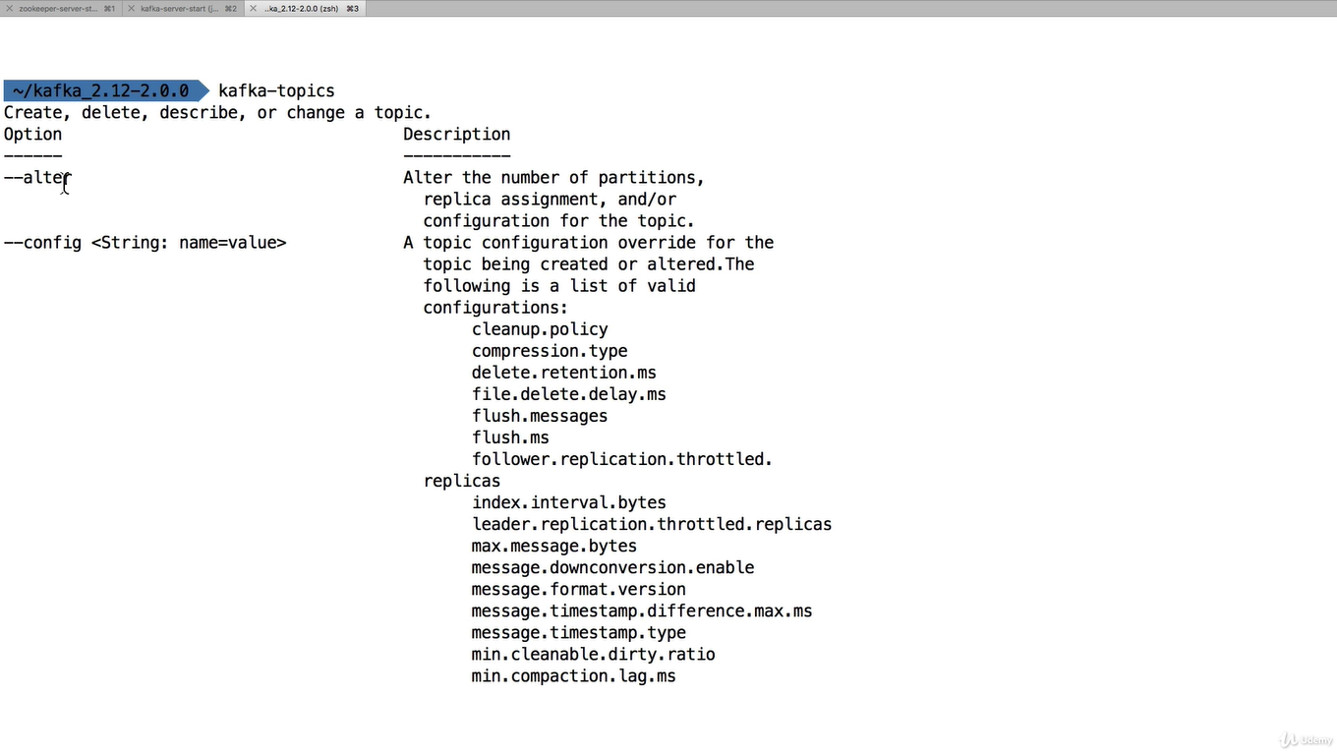

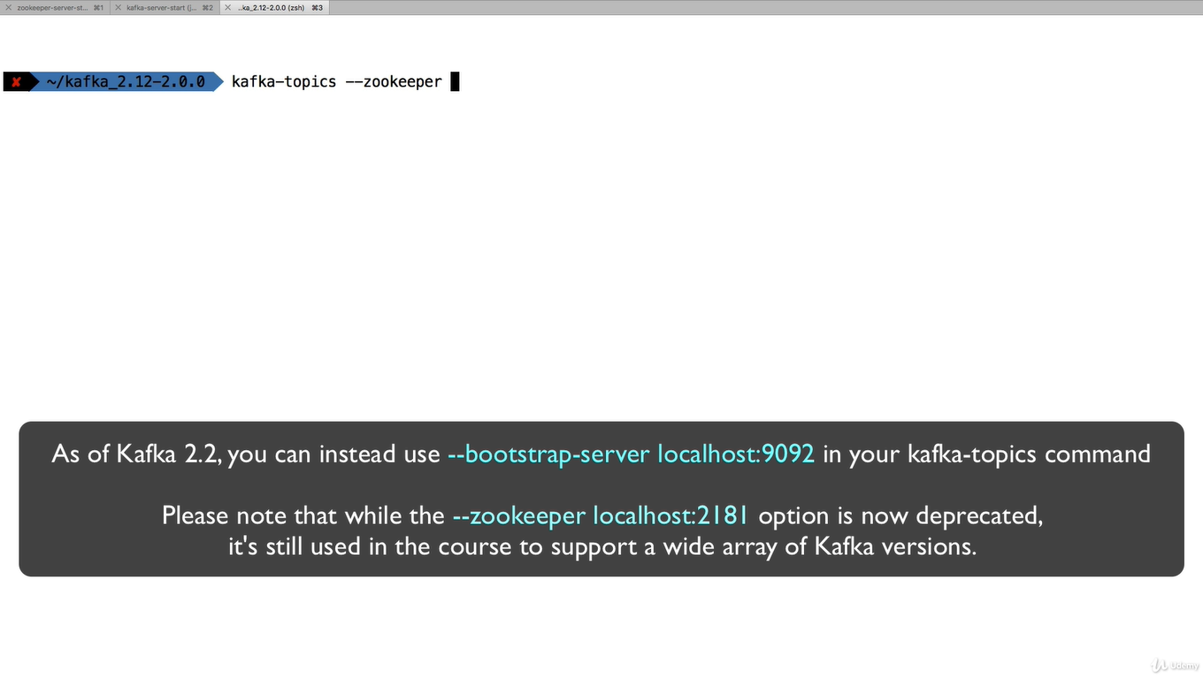

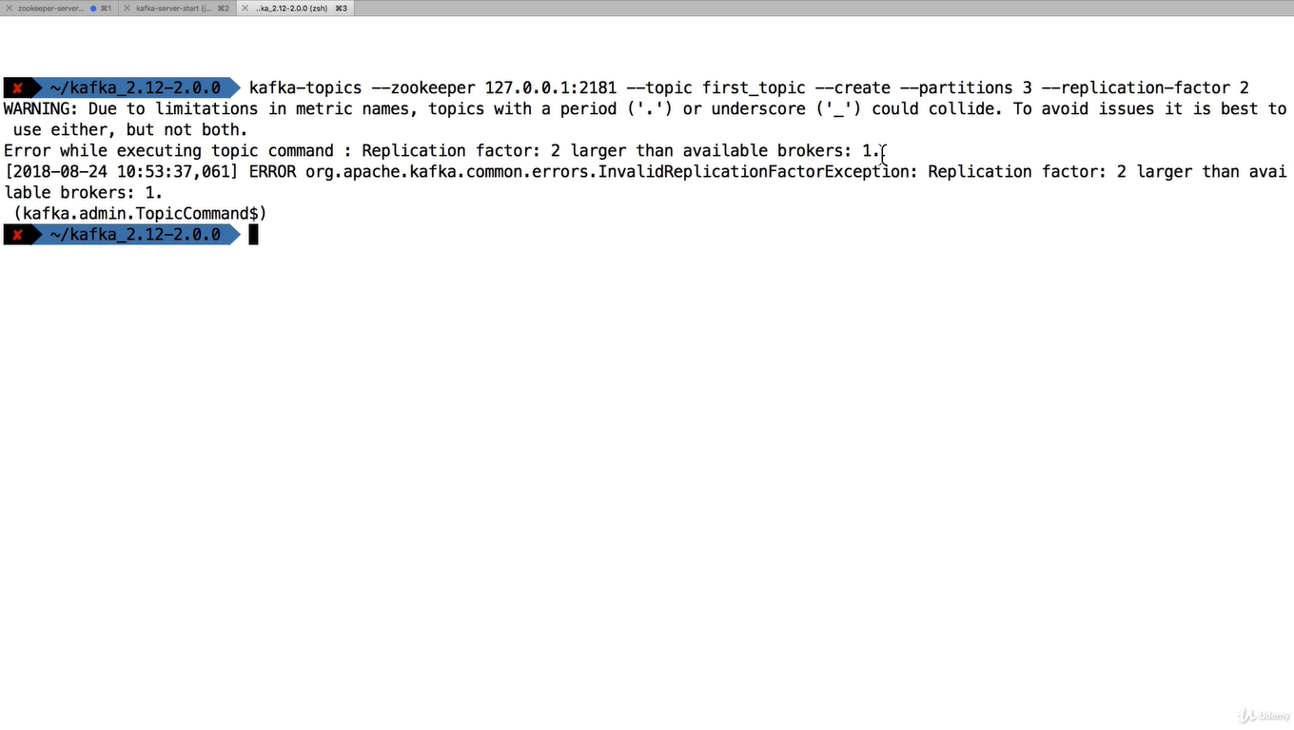

**There is error because you can not start replication more than the broker count in this course we have just started one zooker and one kafka**

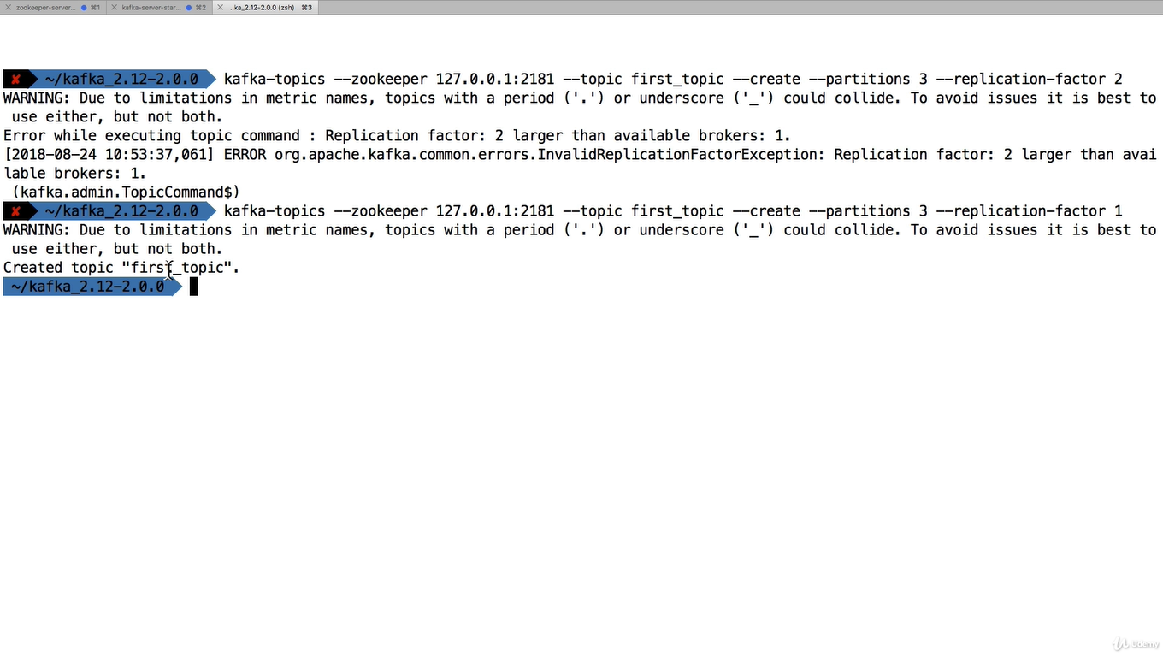

**To list the topics**

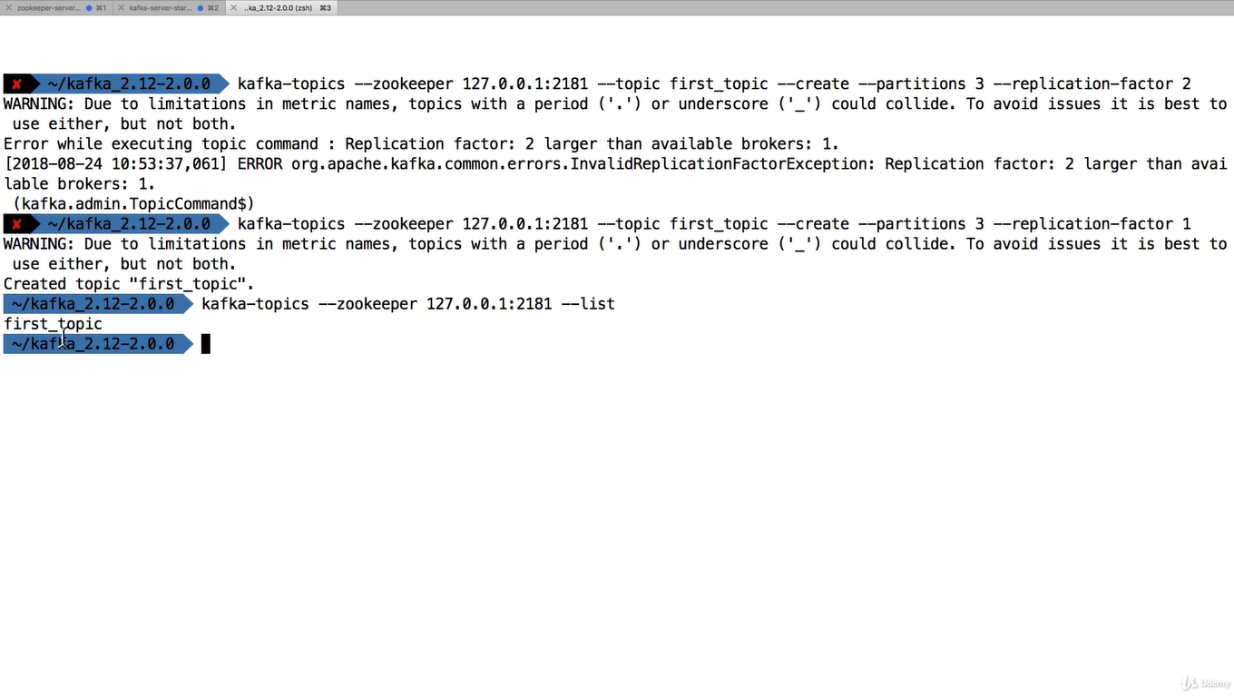

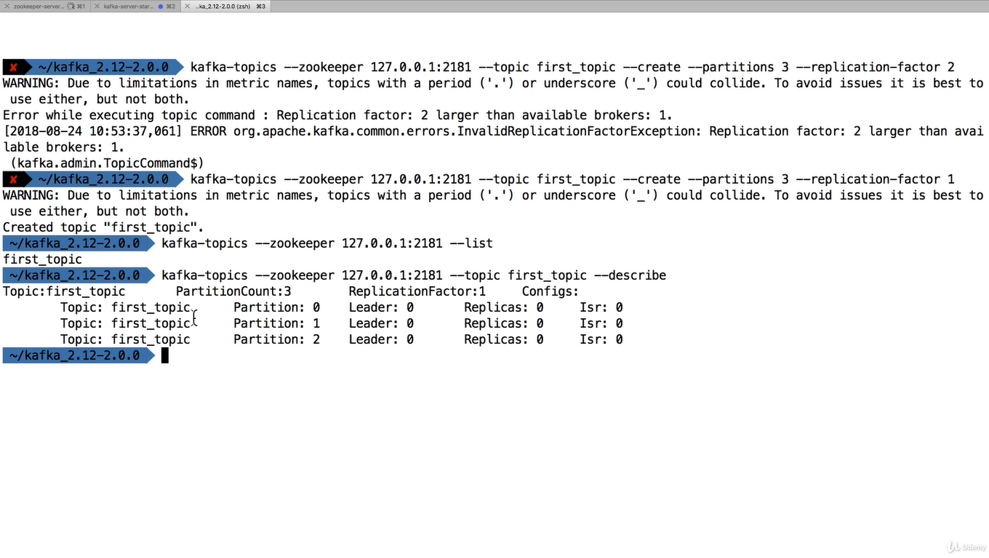

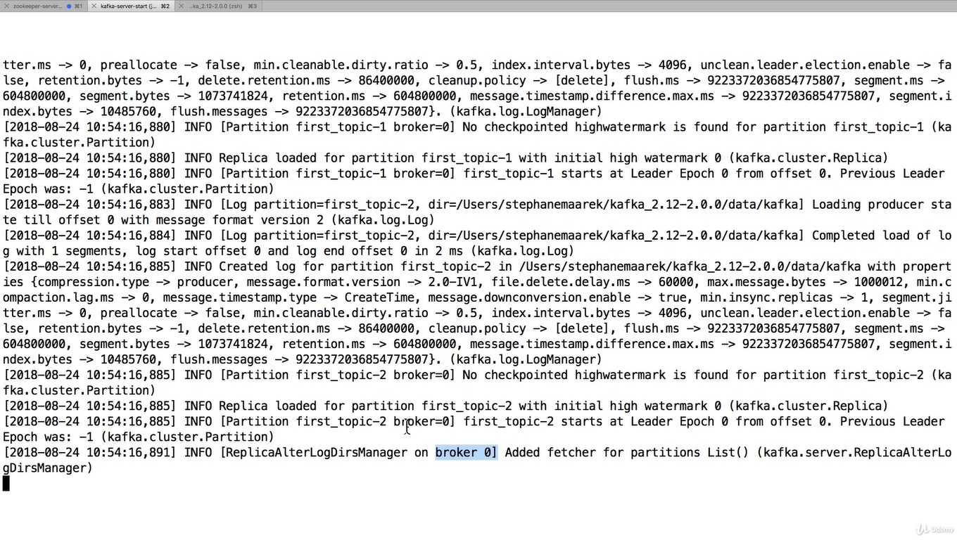

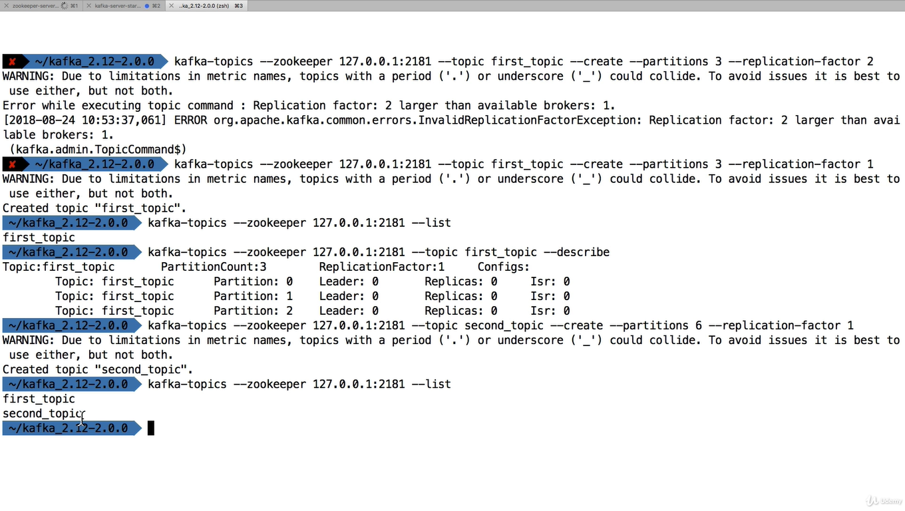

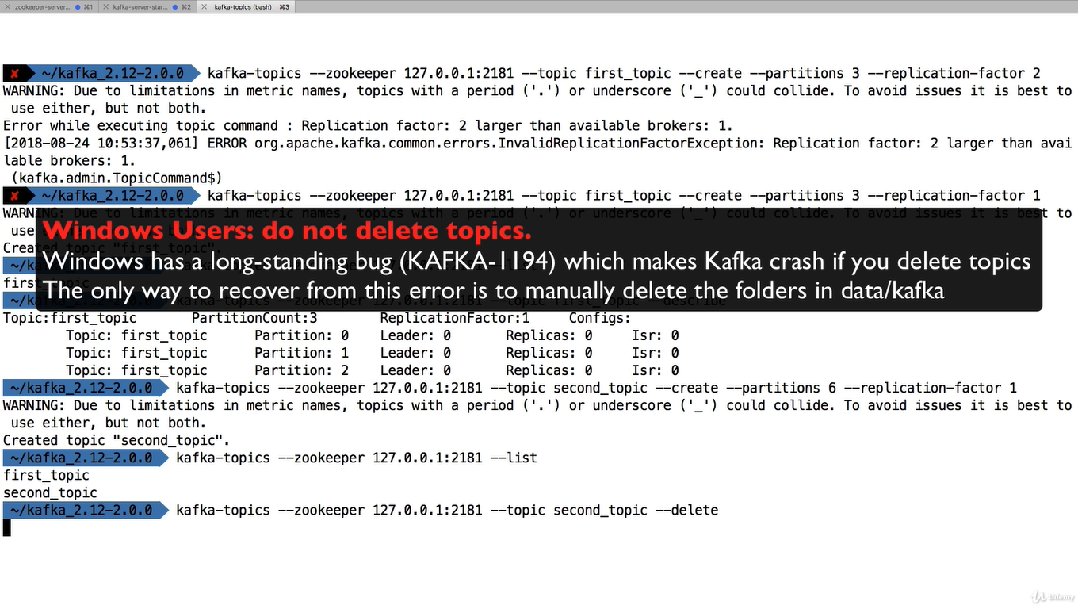

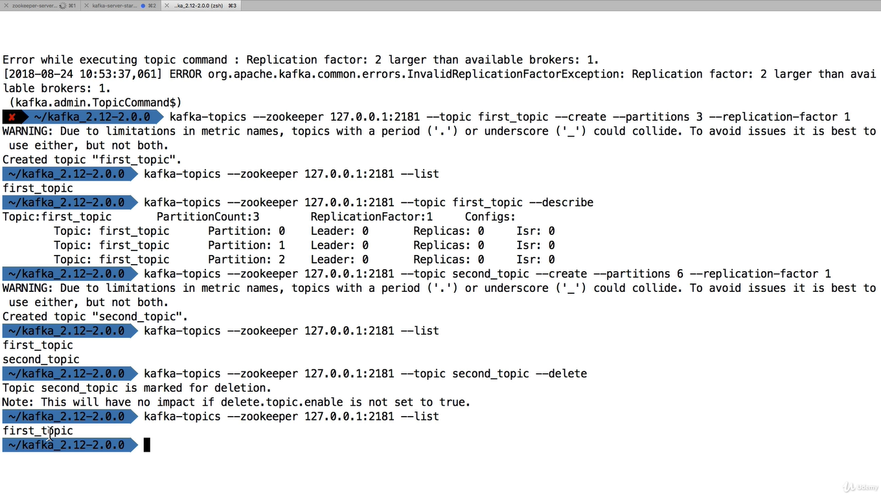

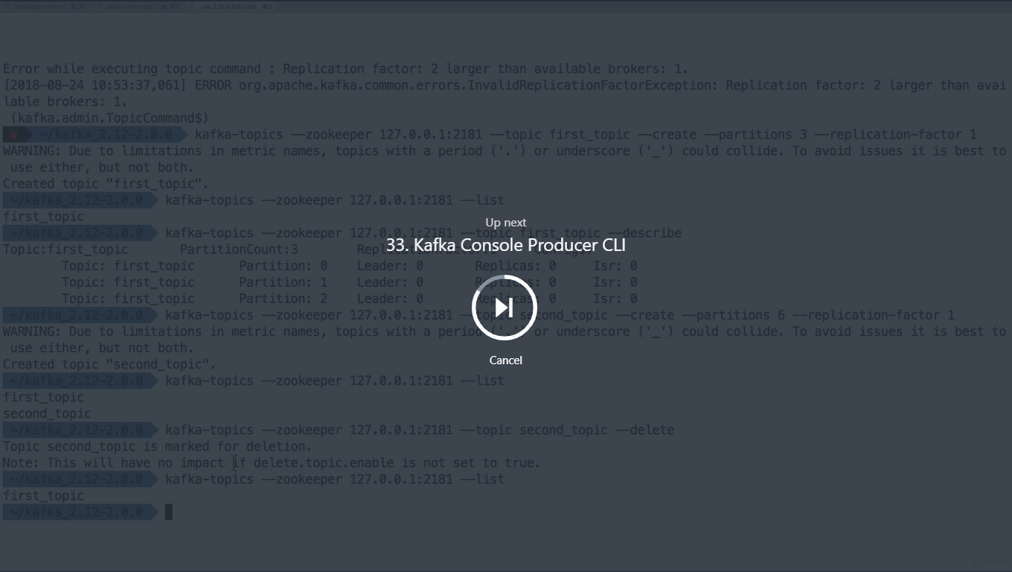

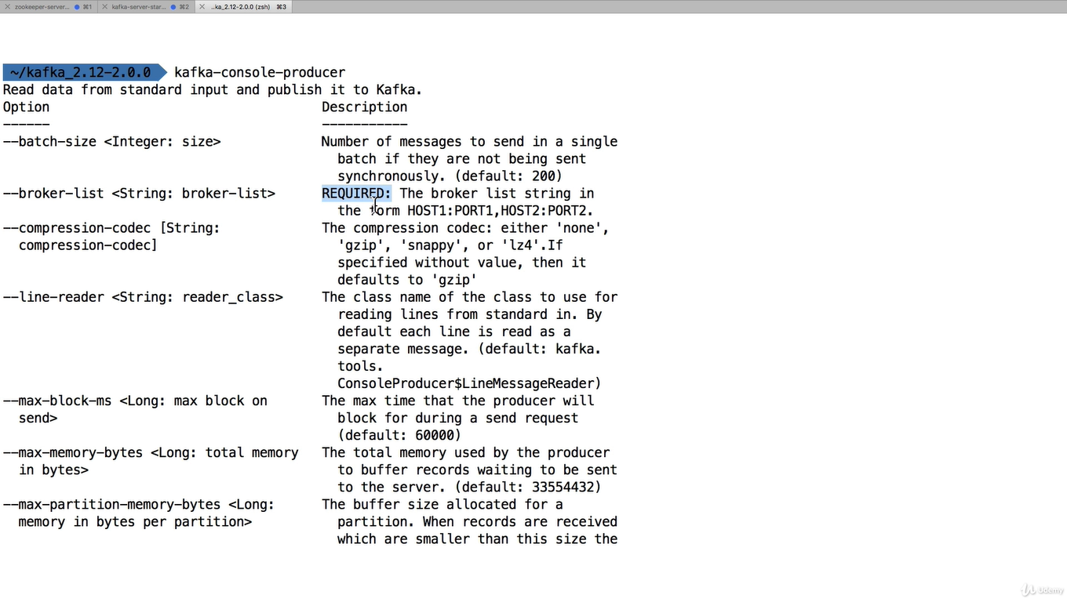

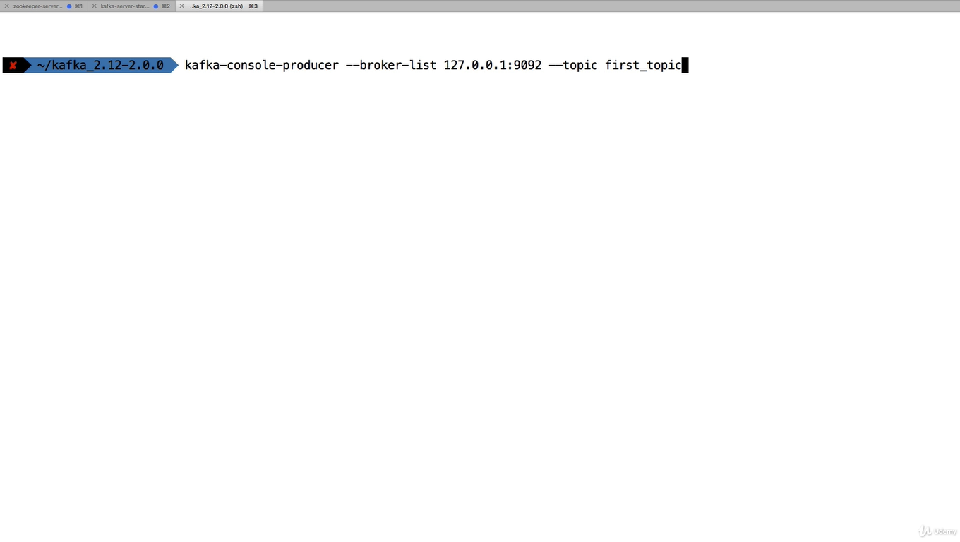

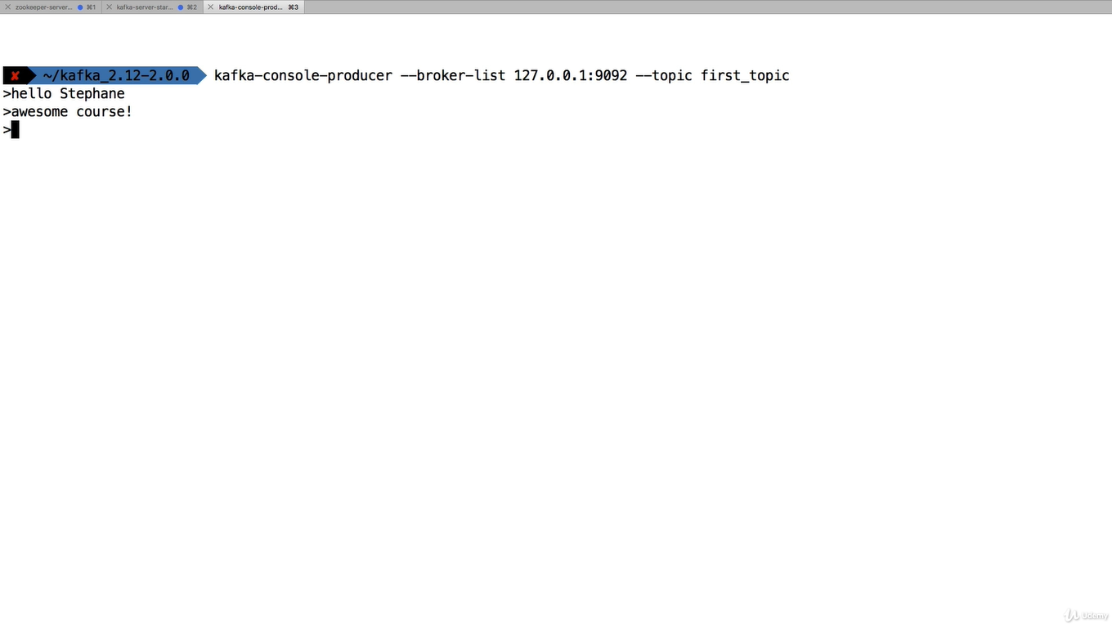

**Stopped the producer**

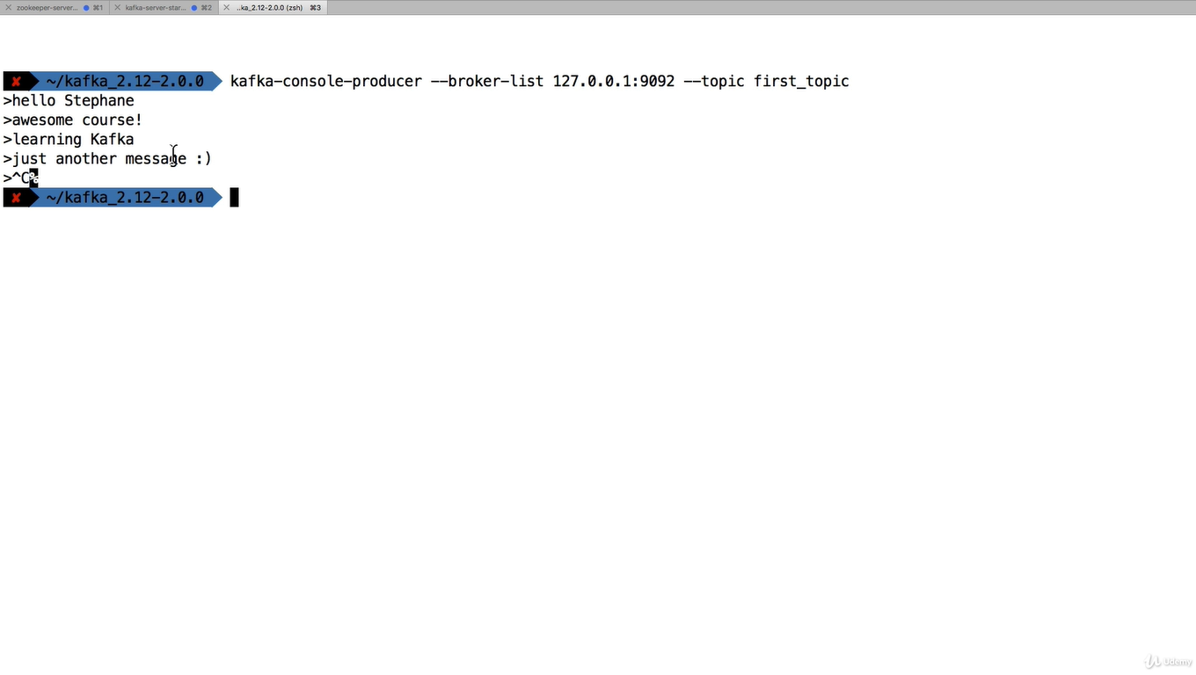

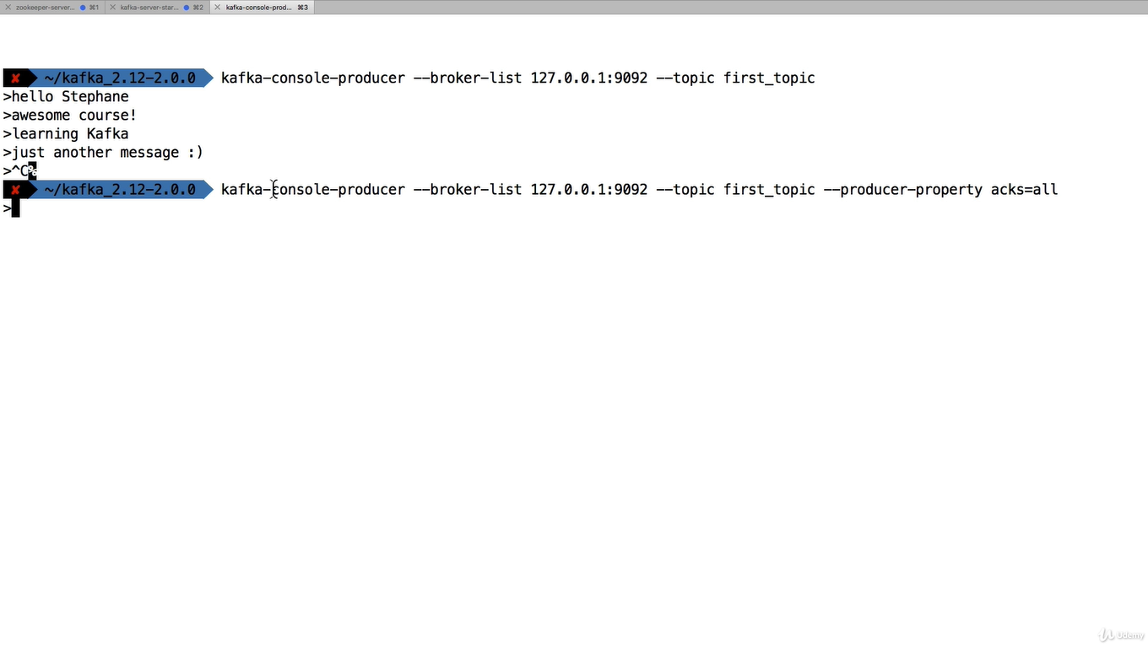

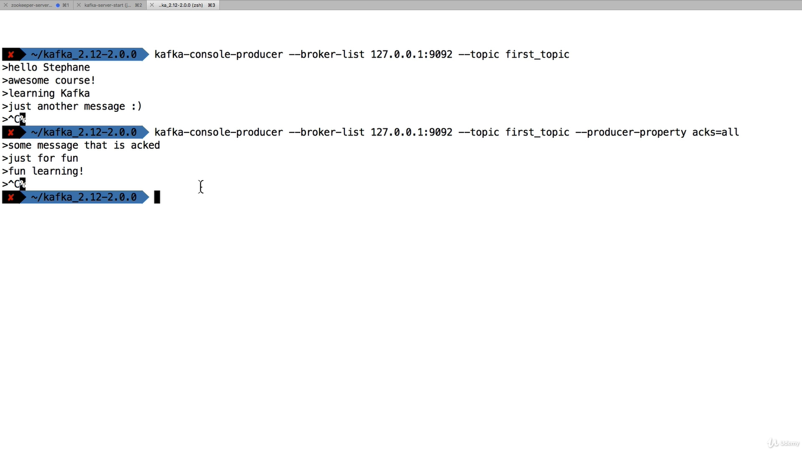

**When we write something if topic does not exist then**

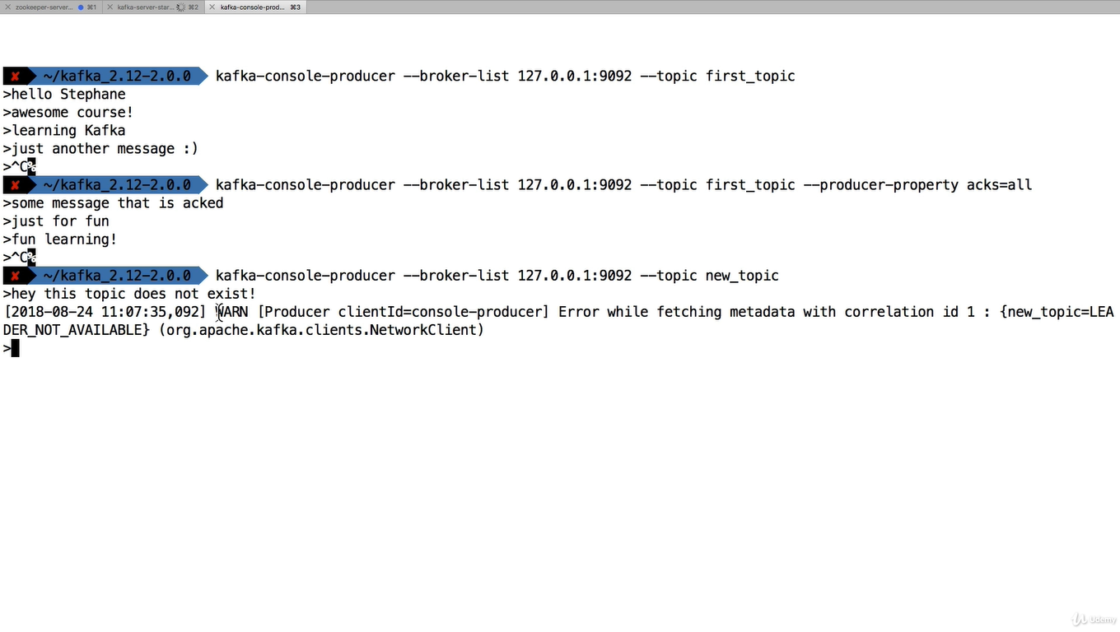

**Here it’s created new topic**

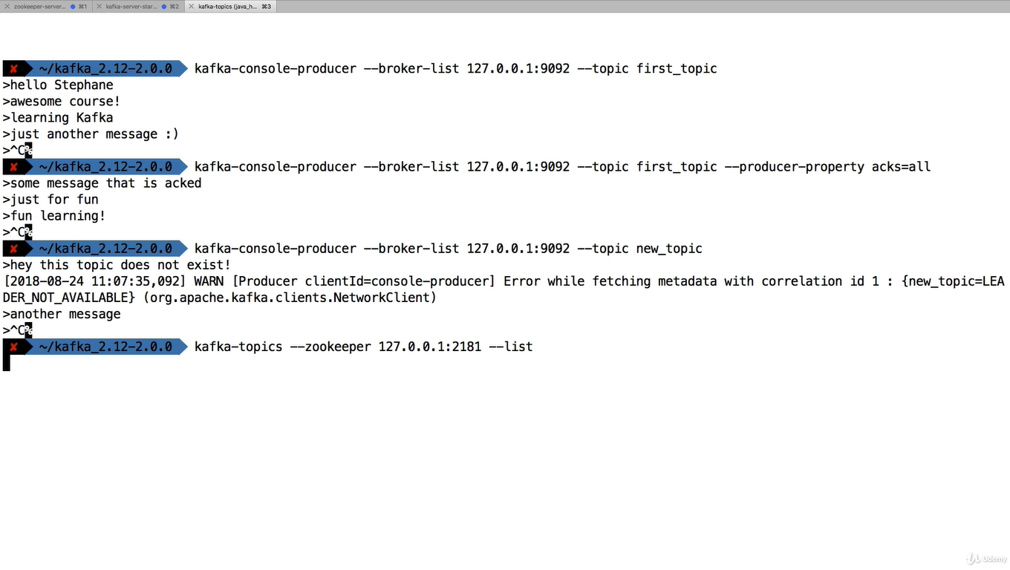

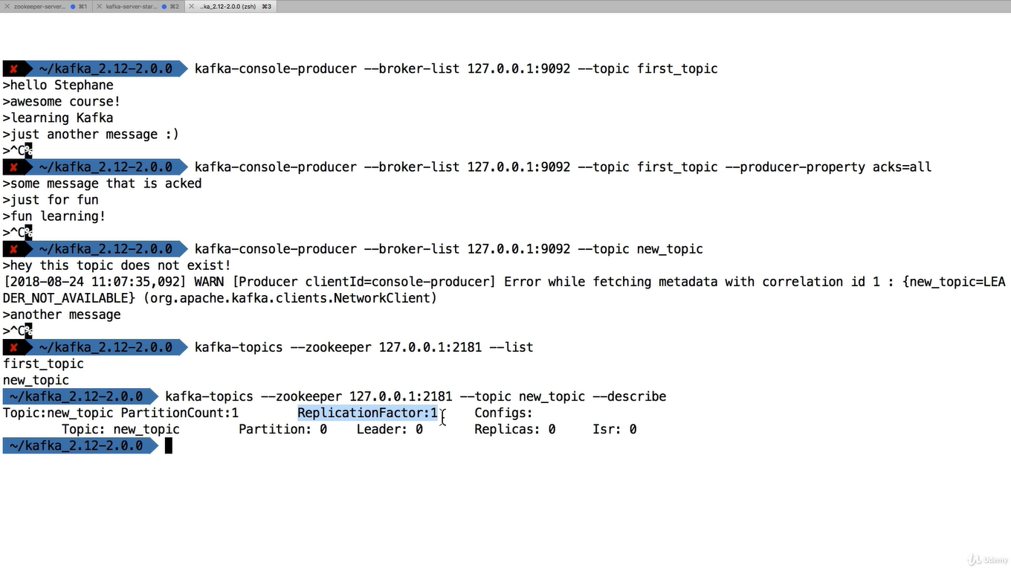

**If the topic does not exist it create new topic with default setting.we can change by going to server.properties**

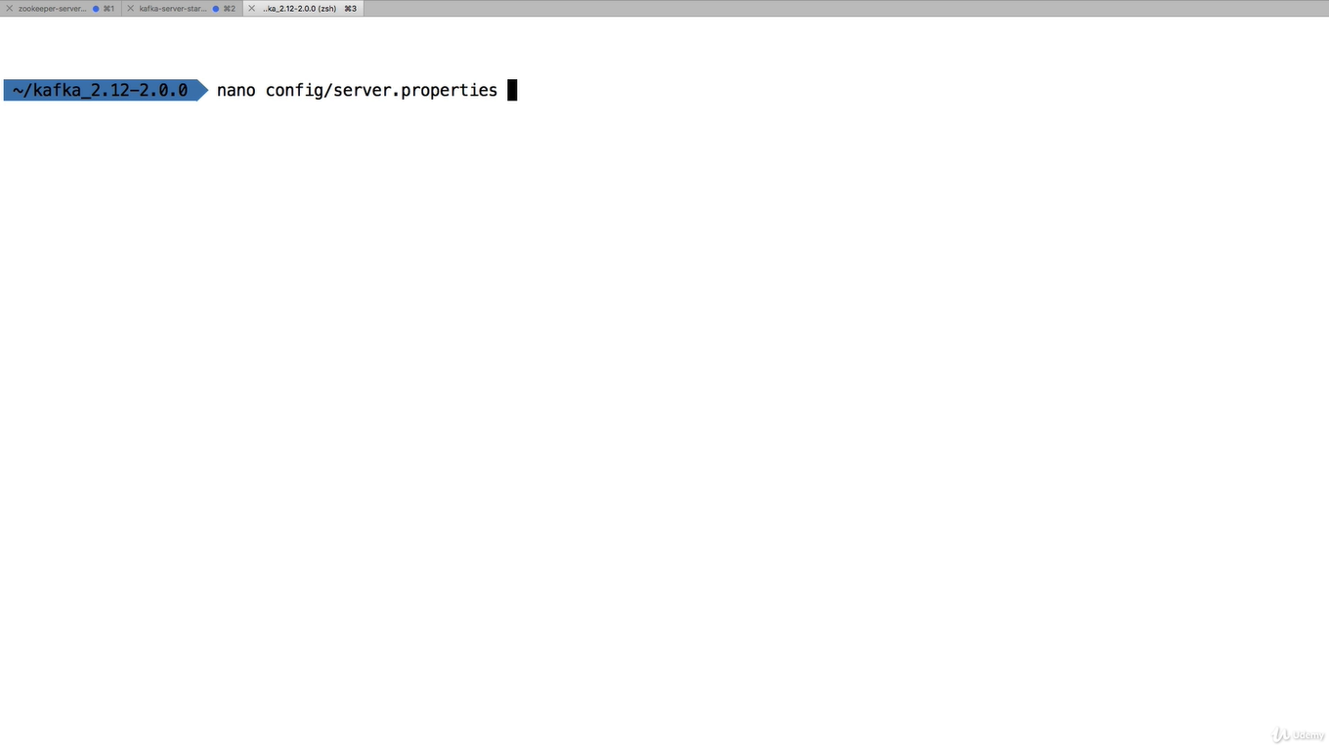

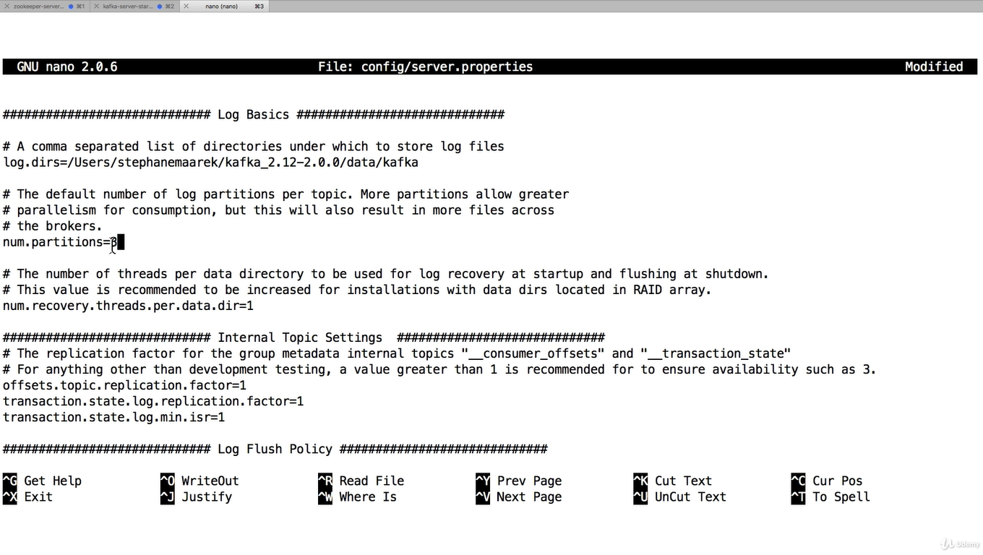

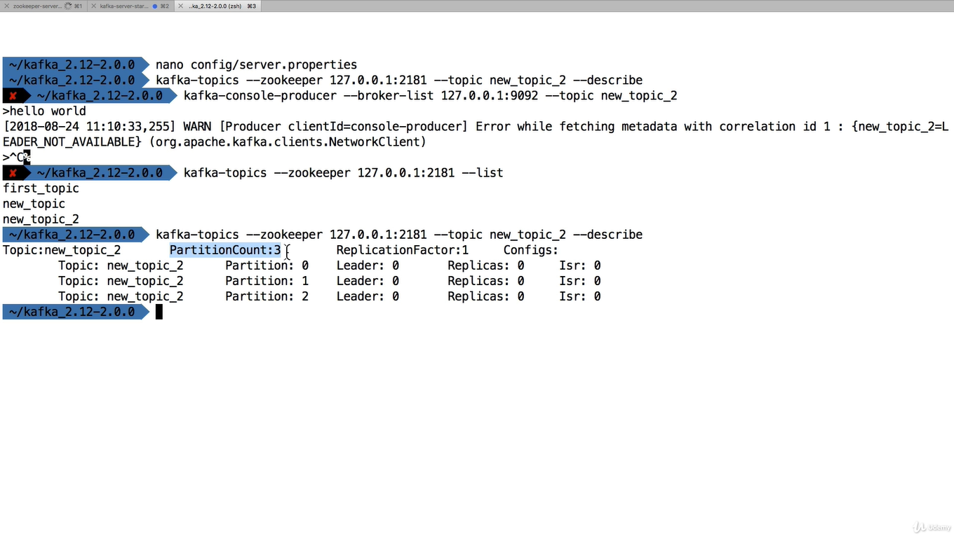

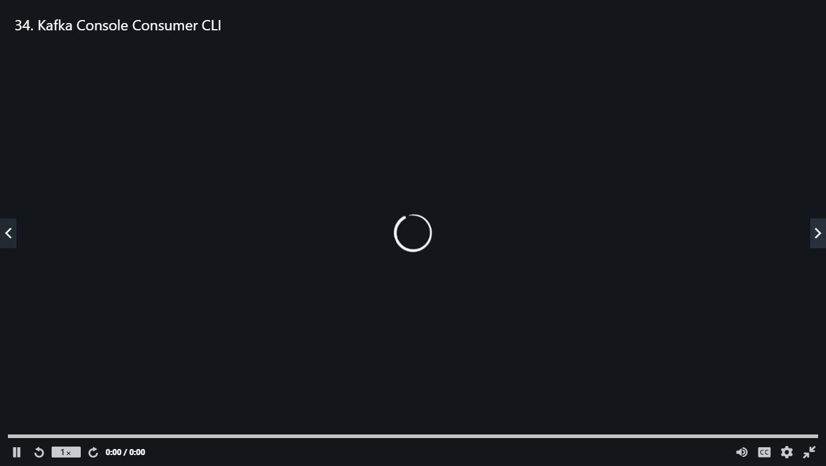



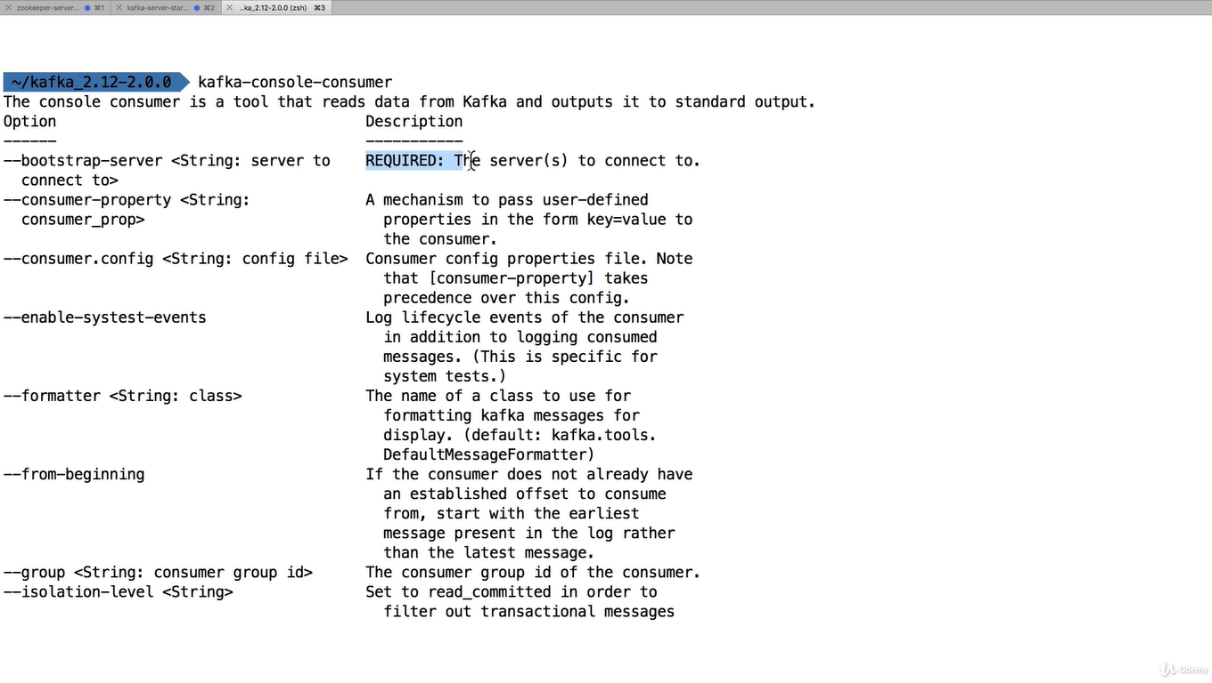

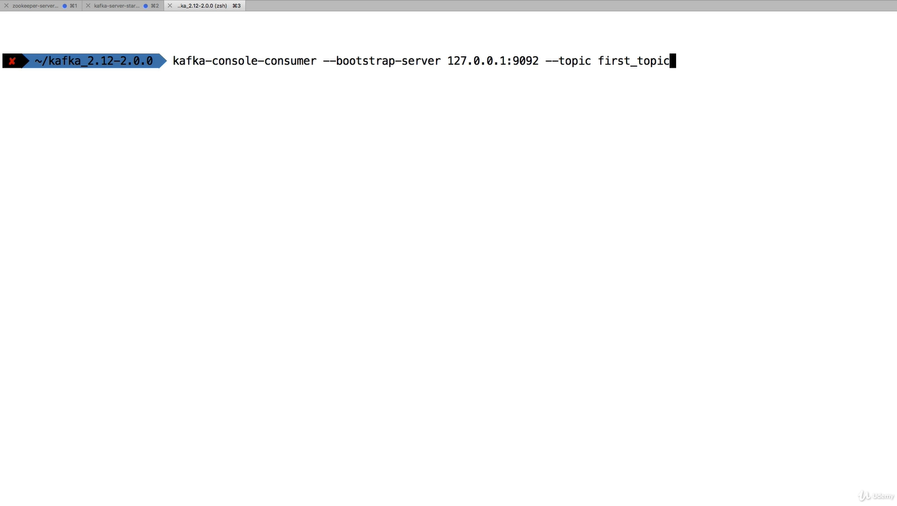

**Nothing happens after this**

**Because kafka listener does not read messages created before we launch the consumer**

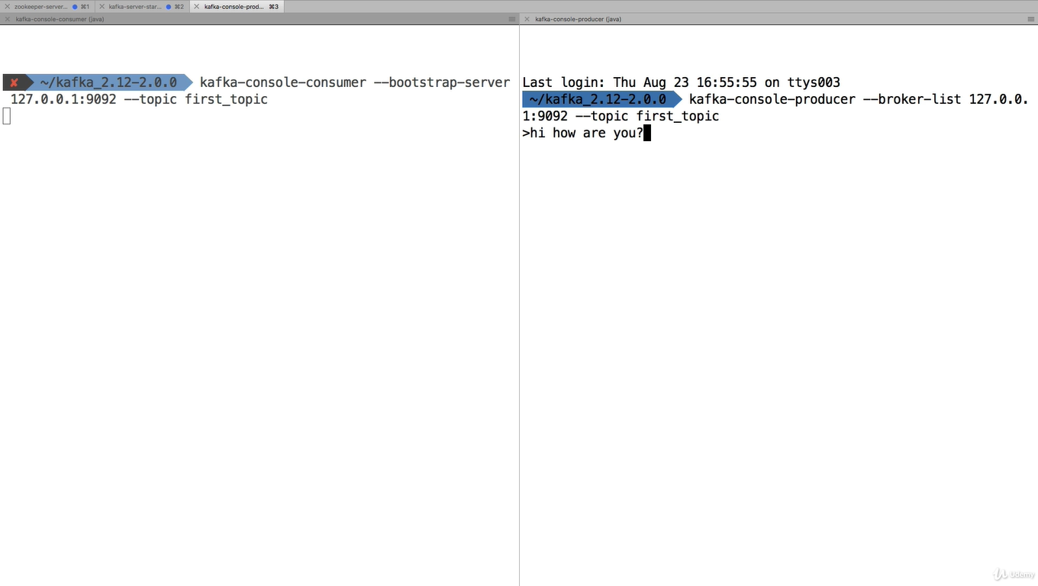

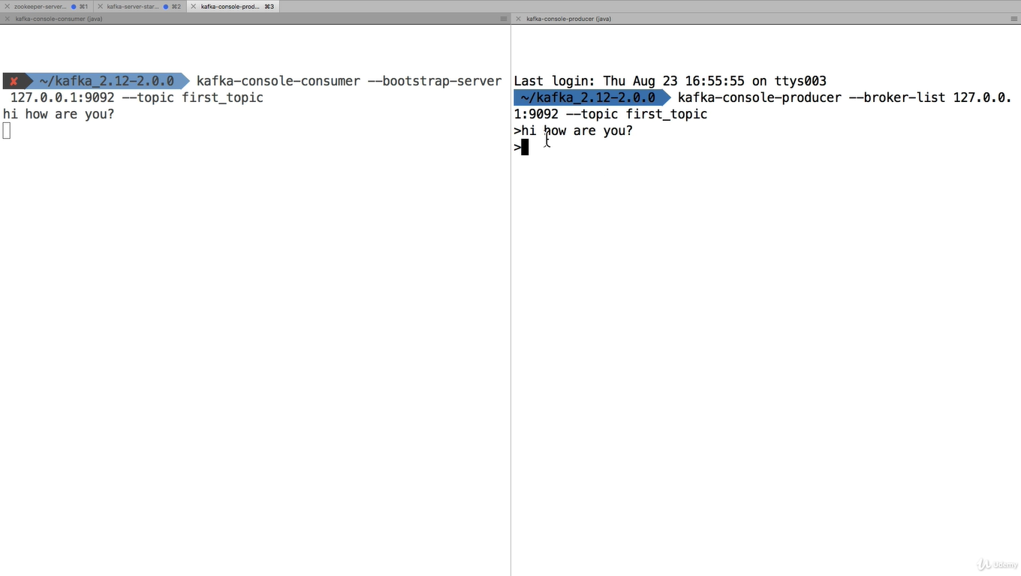

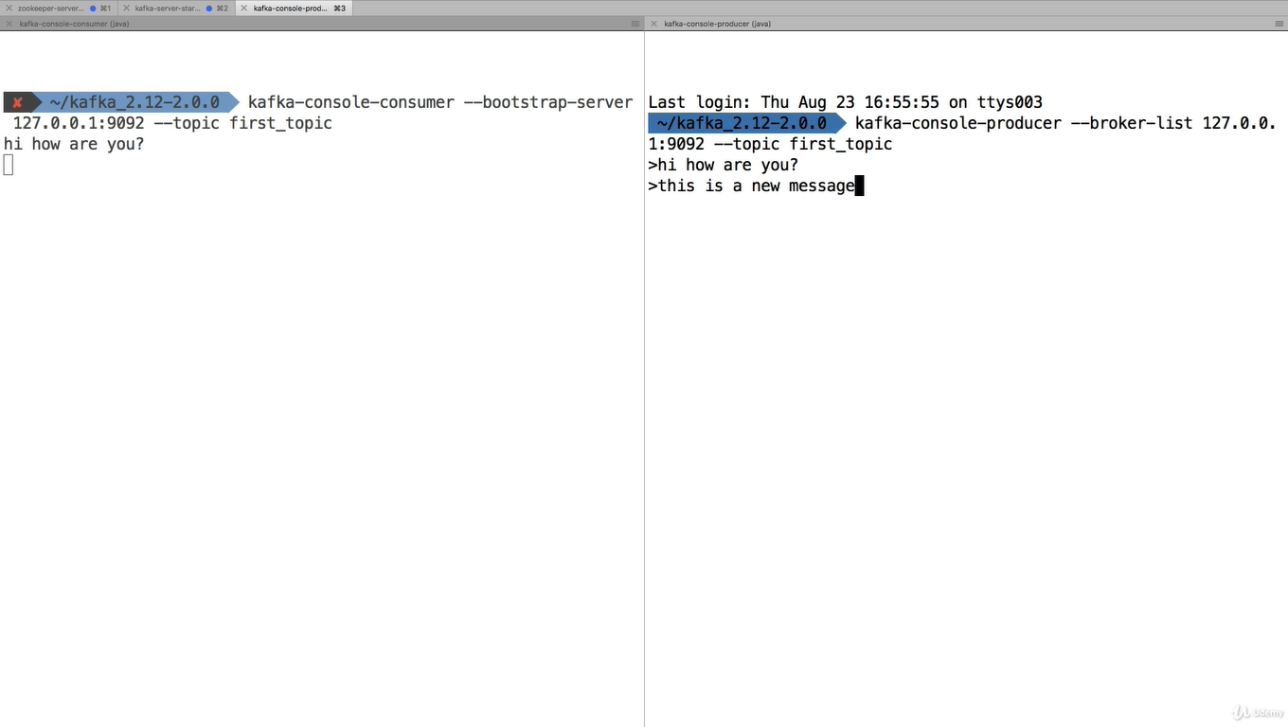

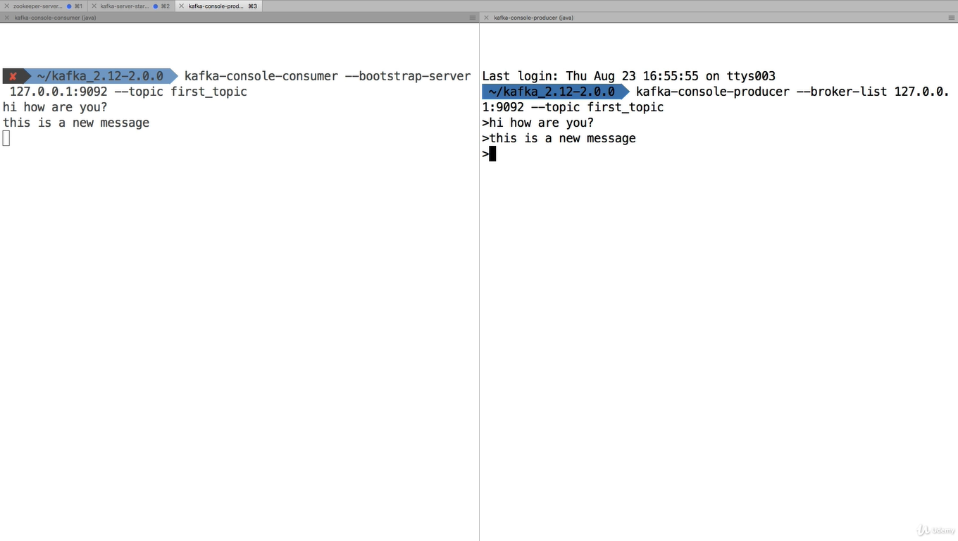

**If you want read all the messages starts from beginning. Then follow below command**

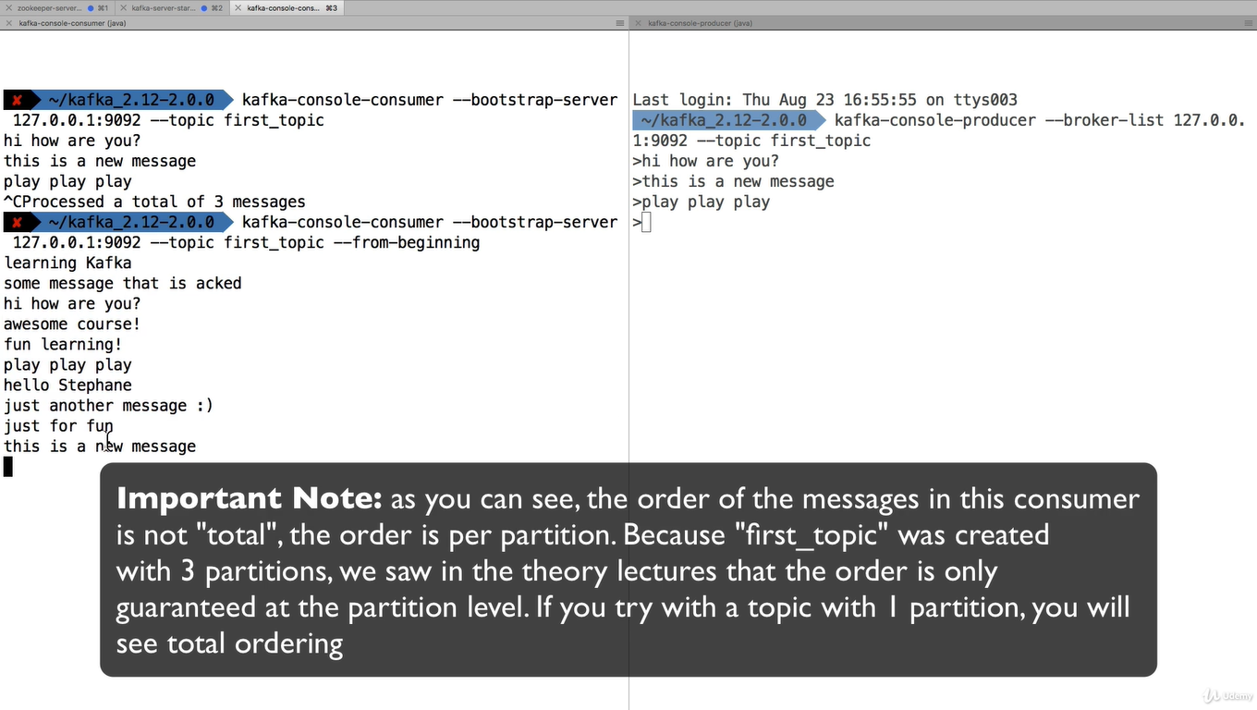

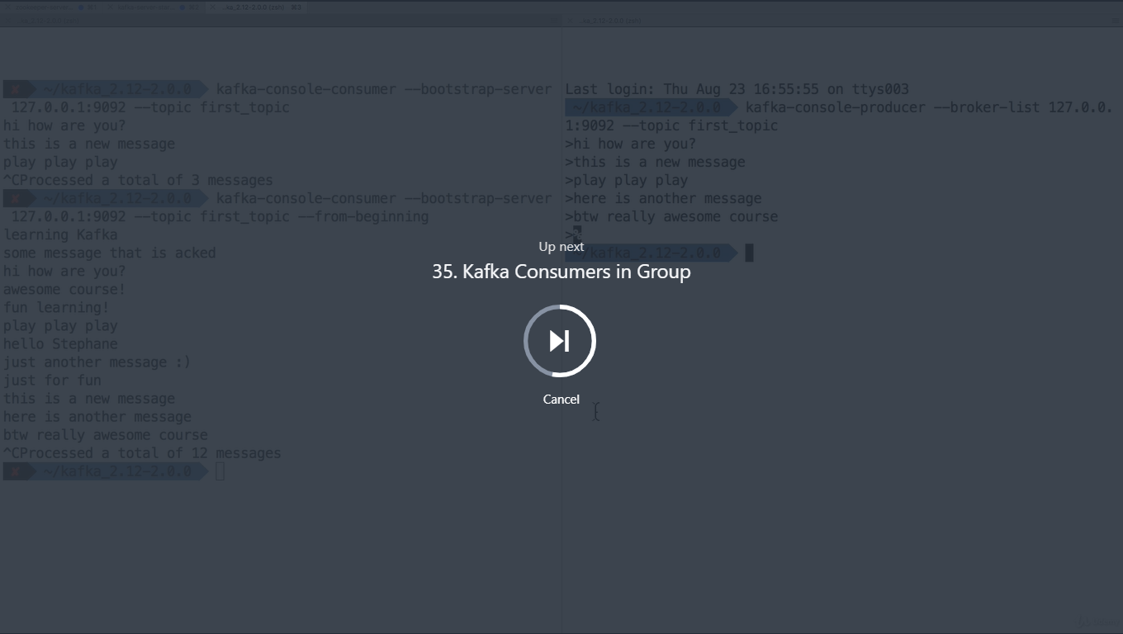

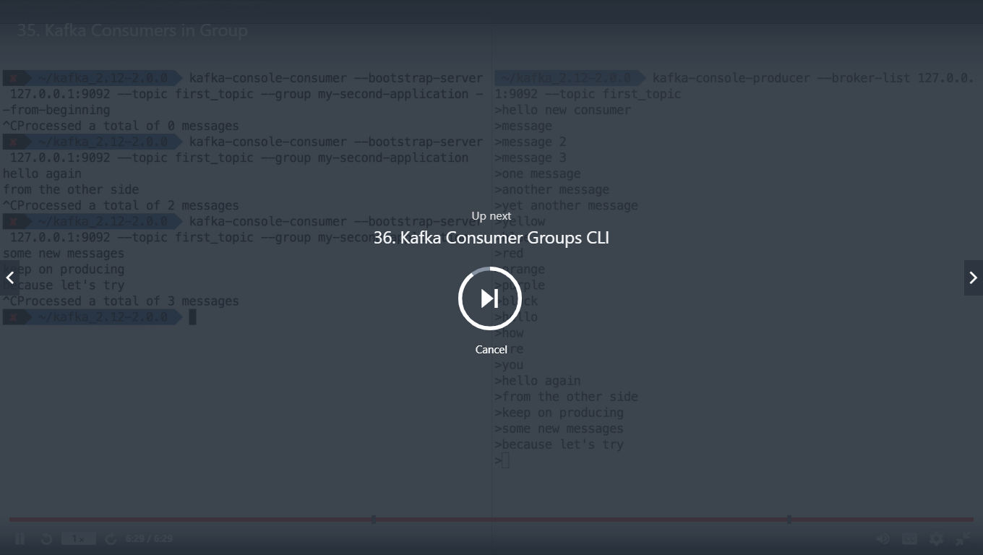

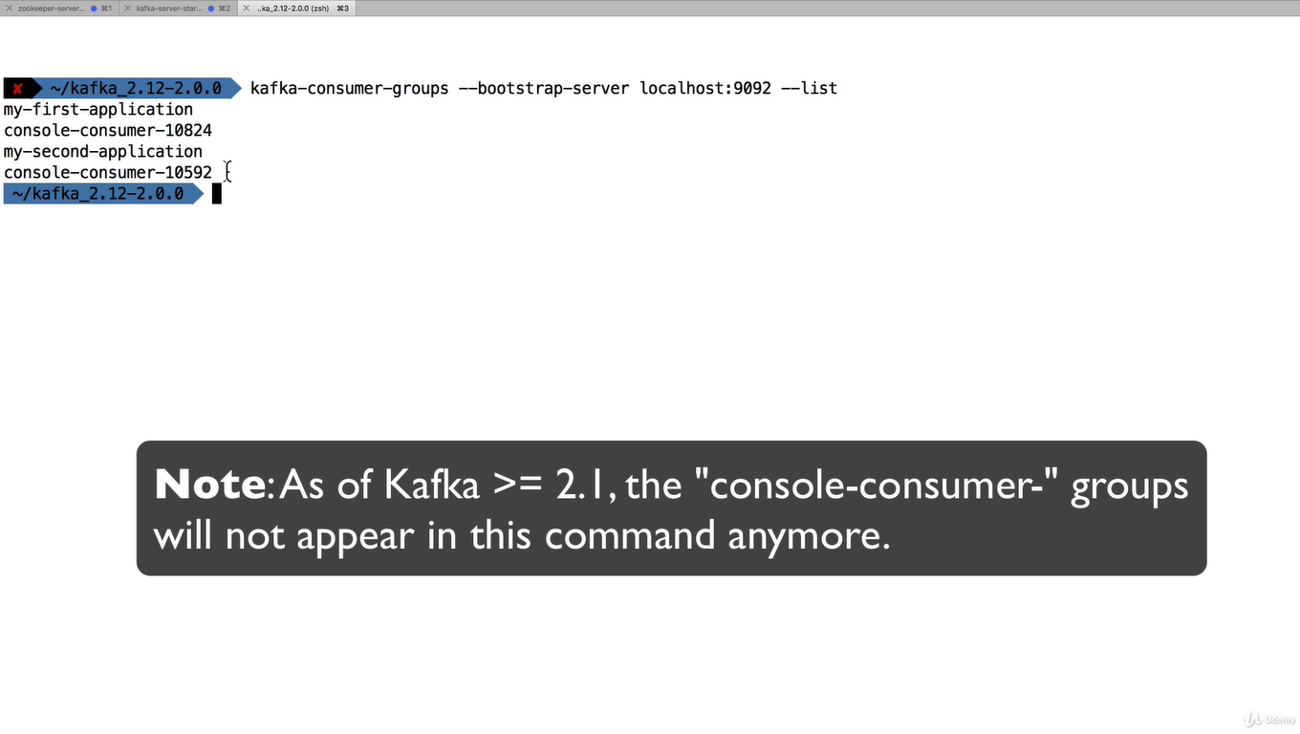

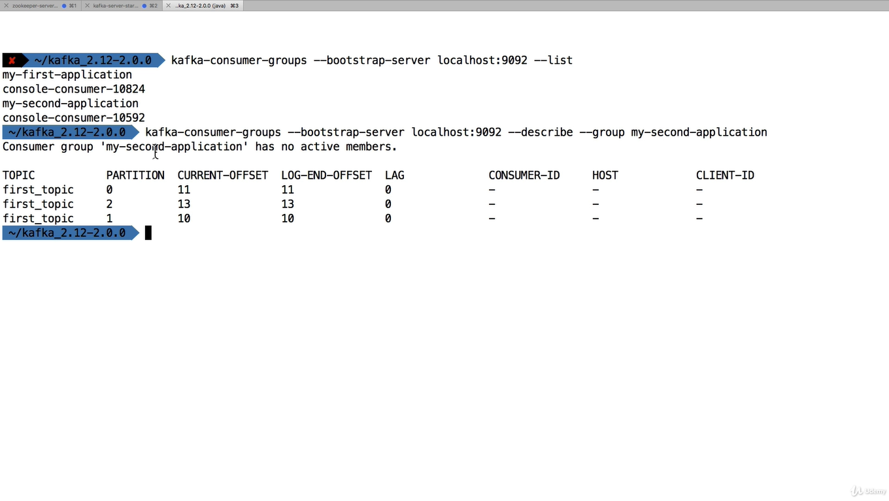

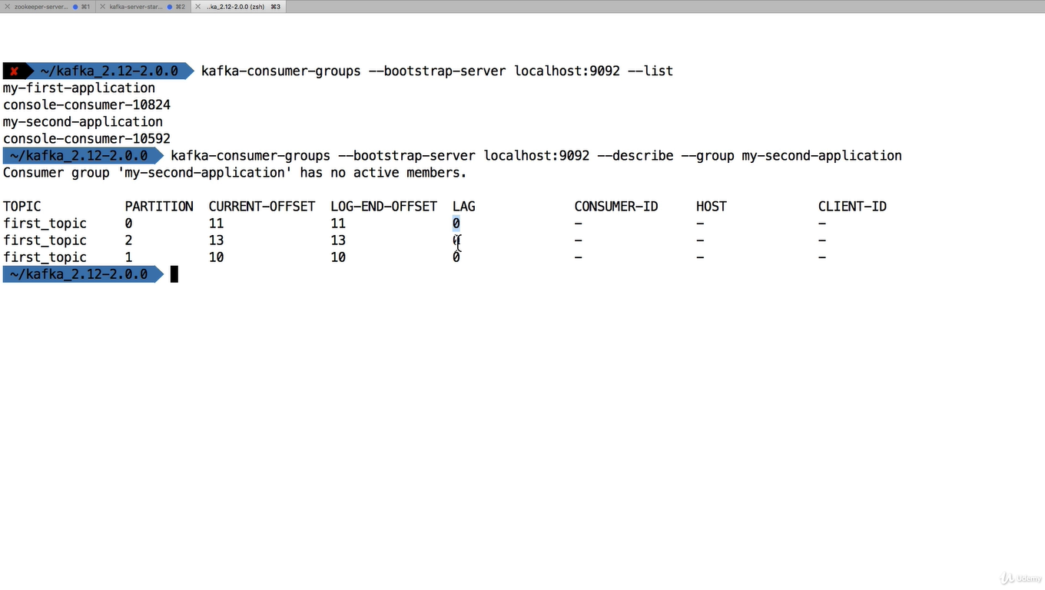

LAG =0 meanin nothing is pending to read

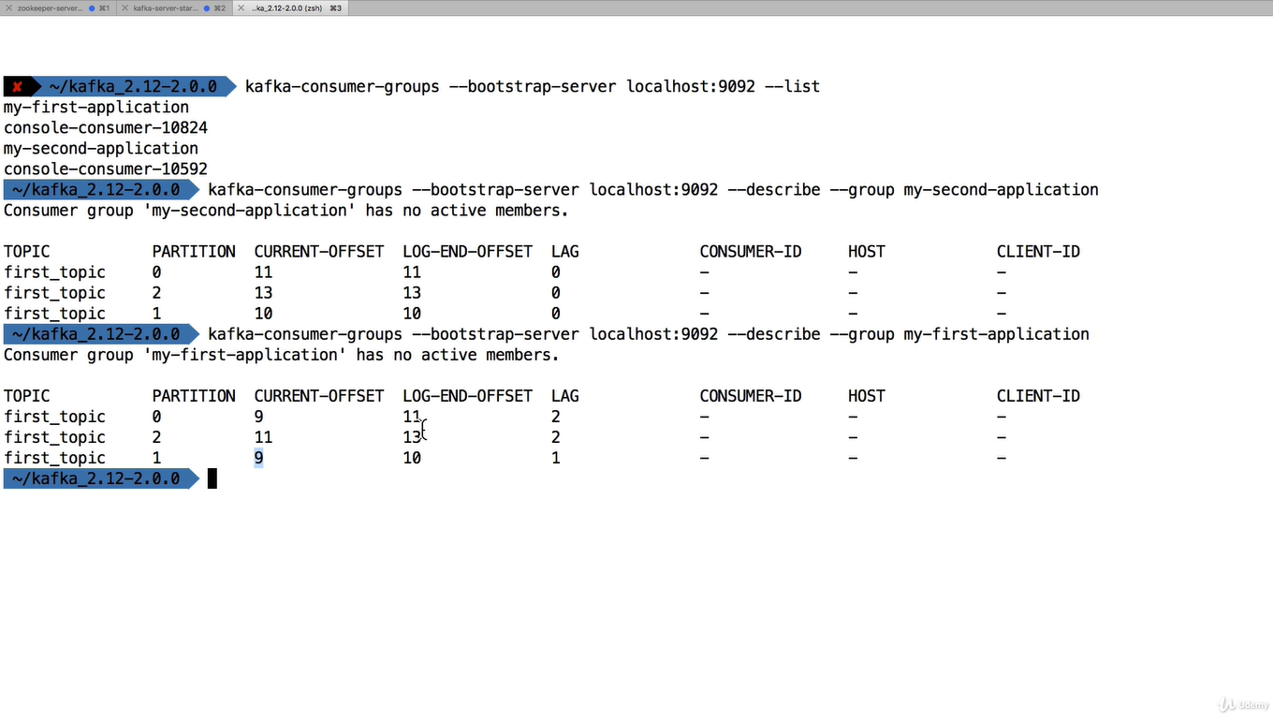

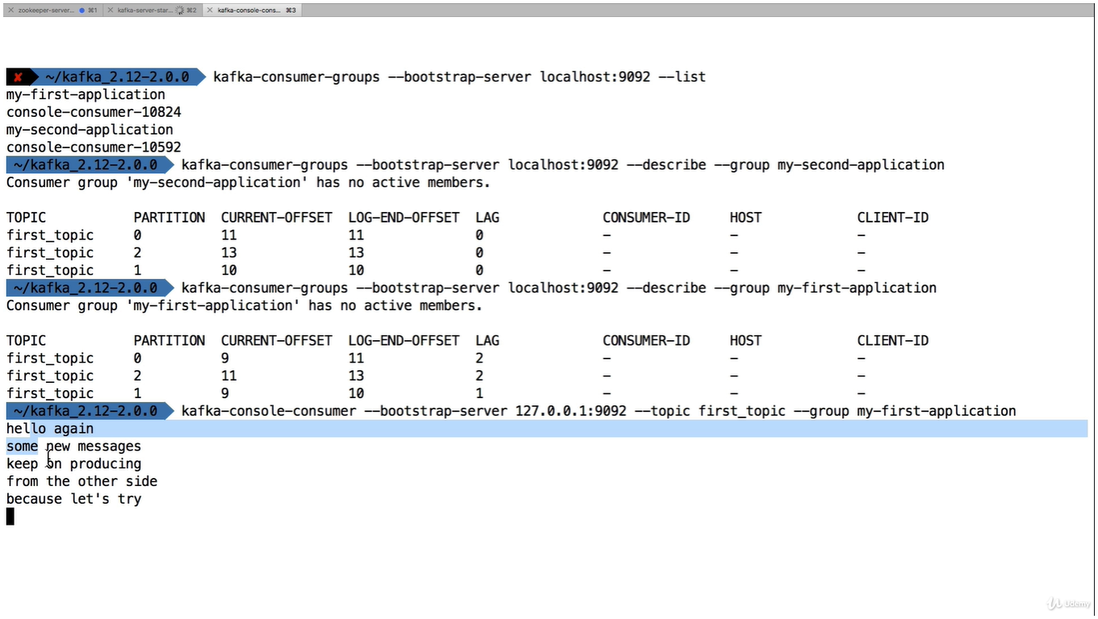

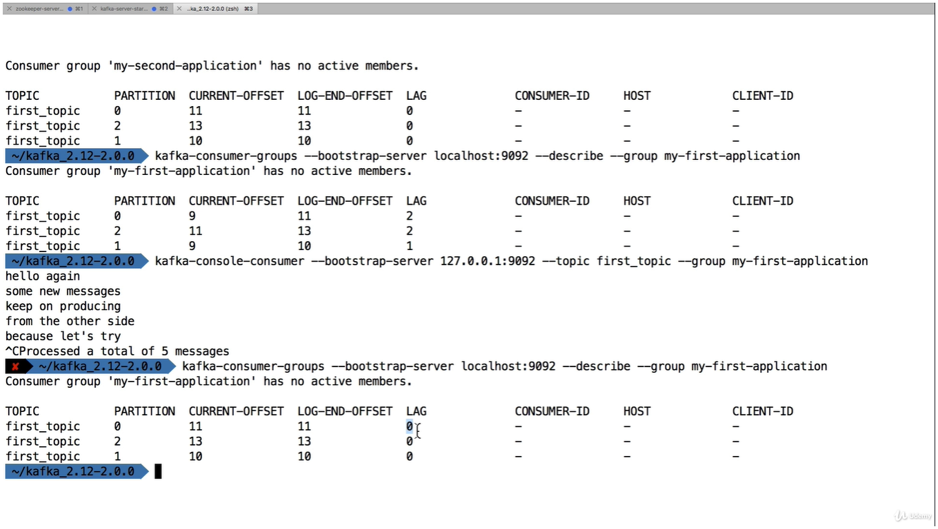

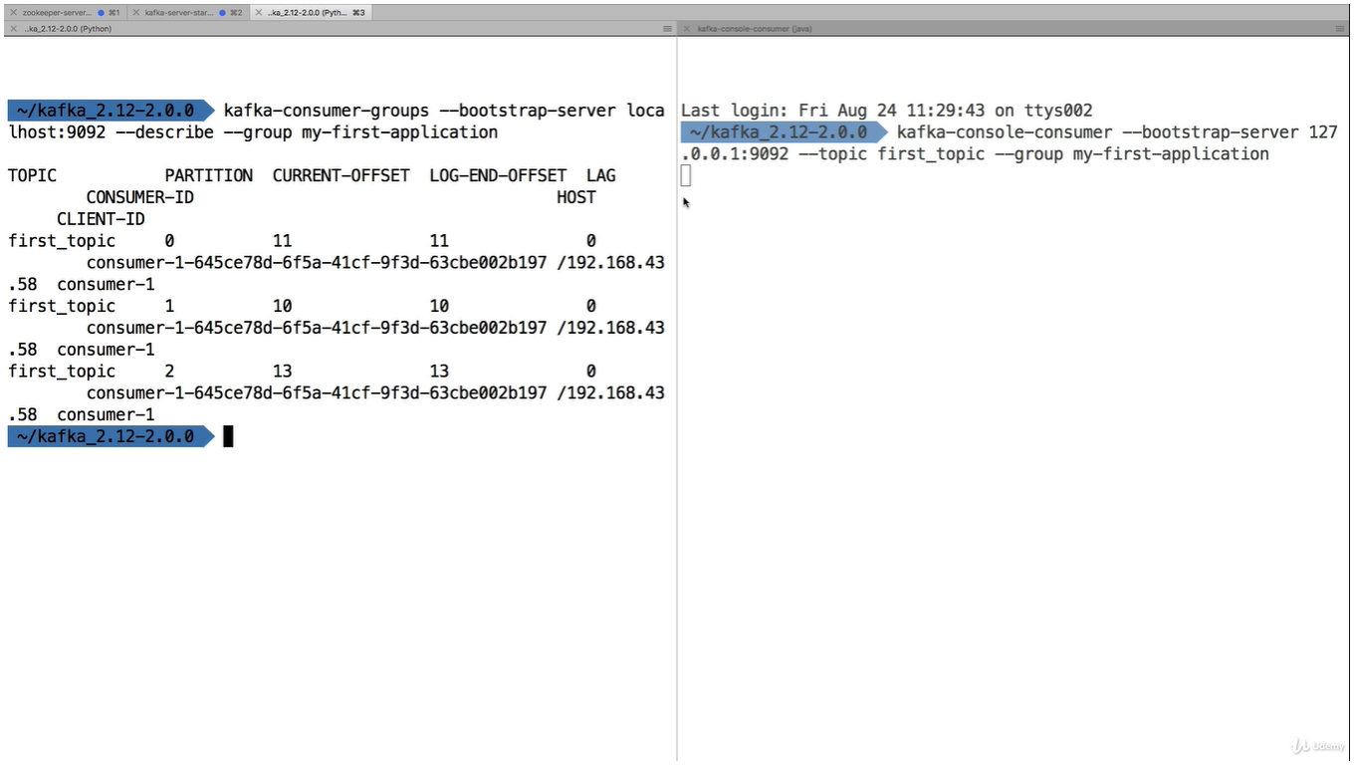

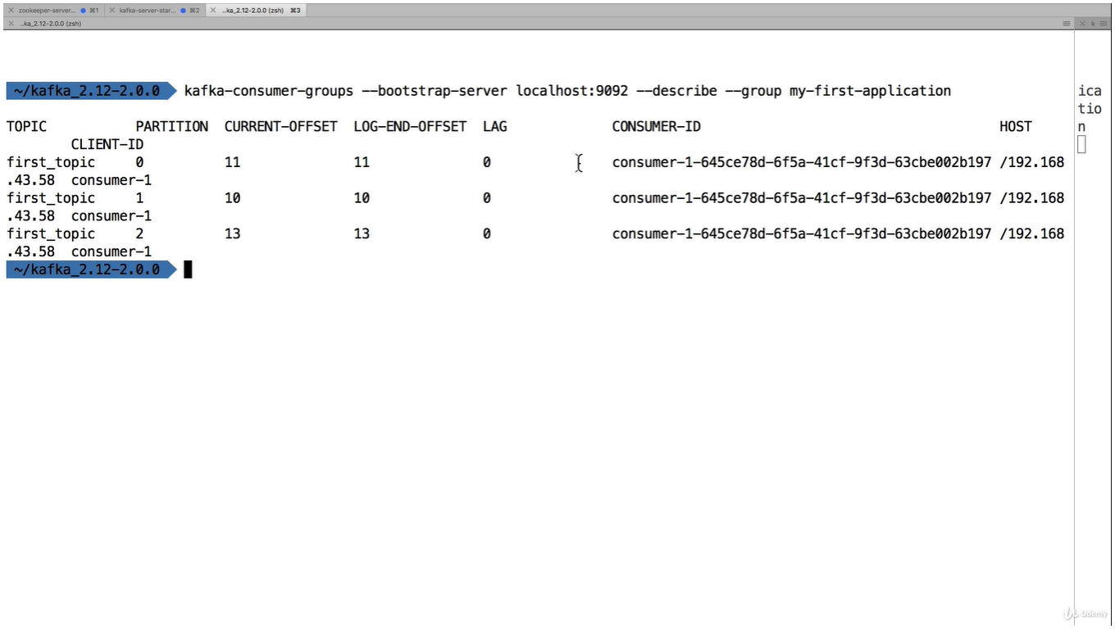

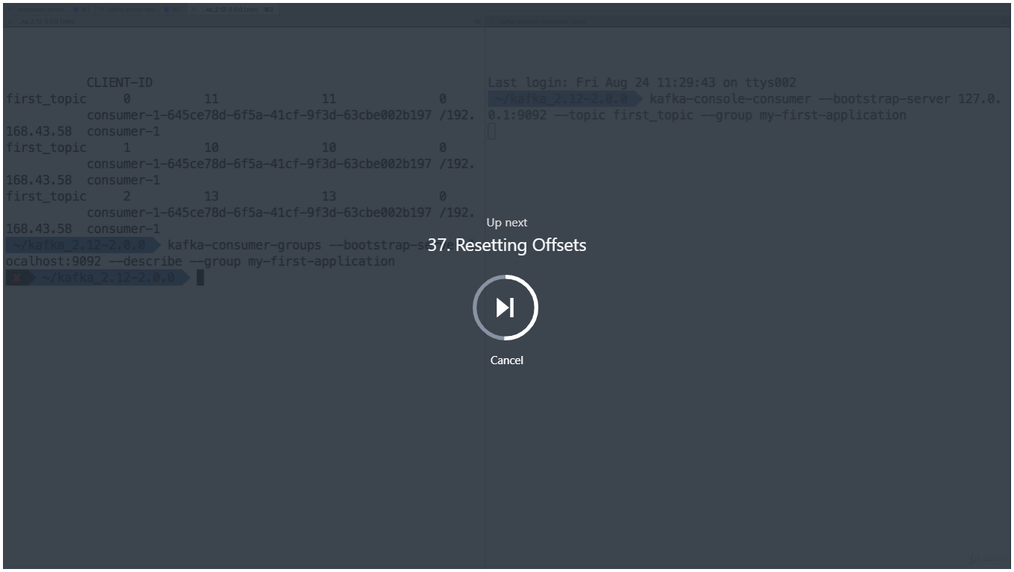

This is replay the data

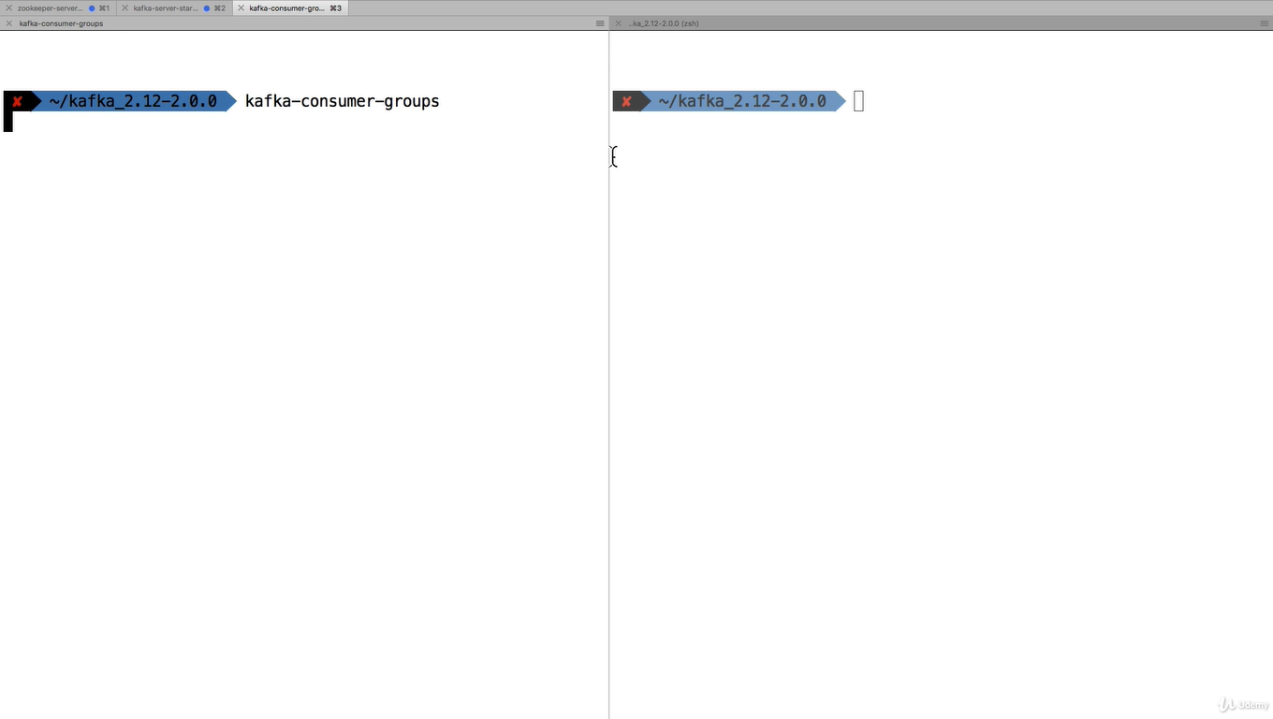

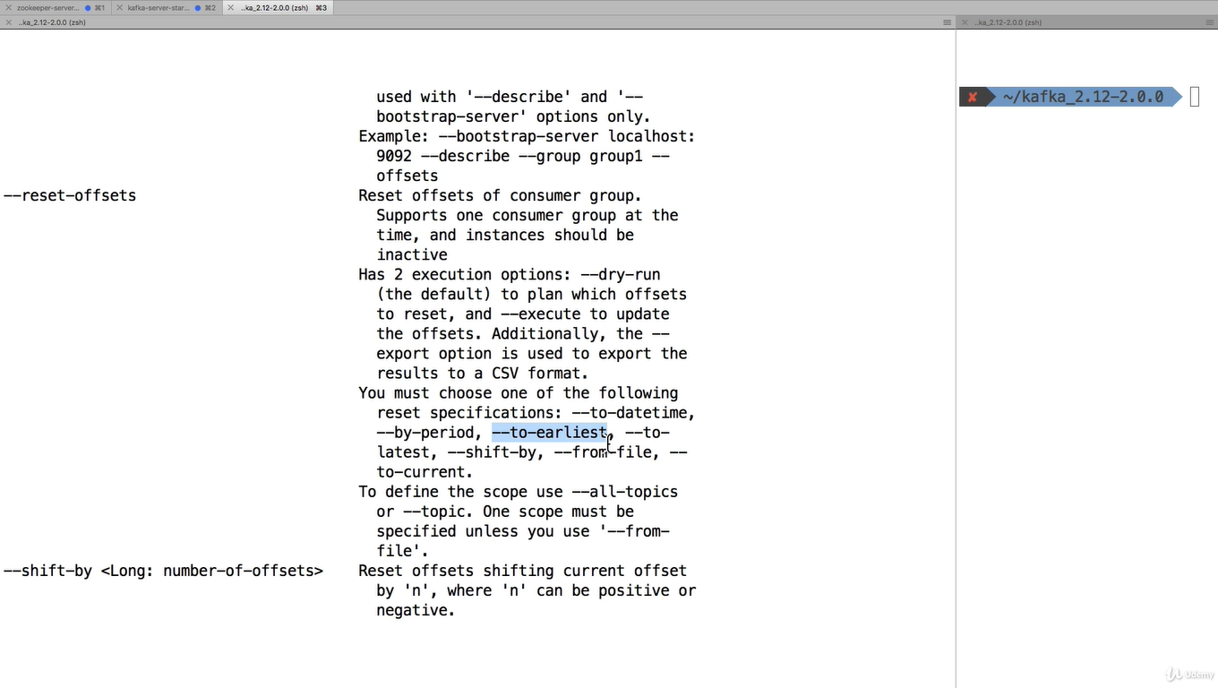

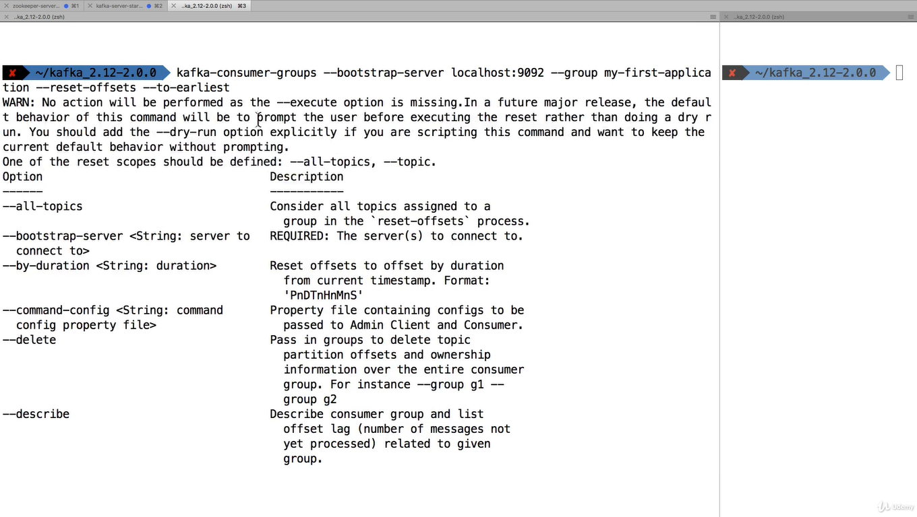

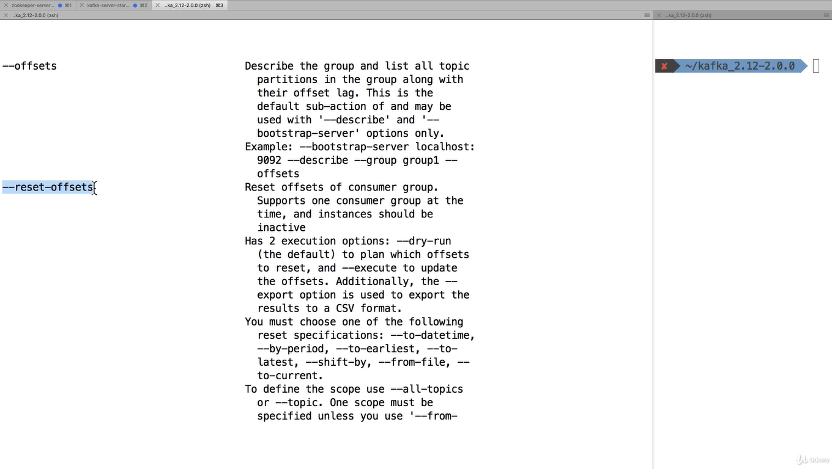

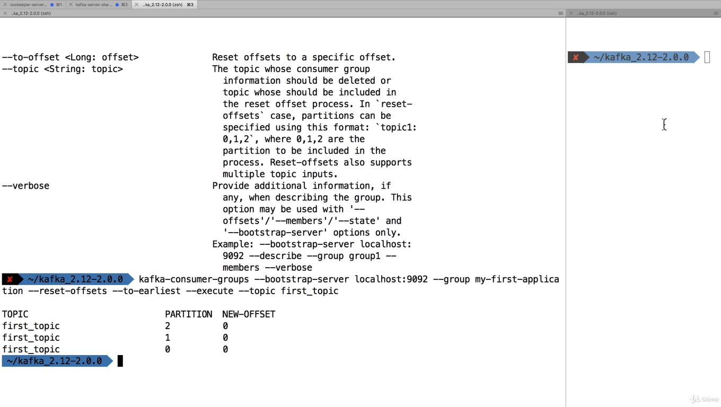

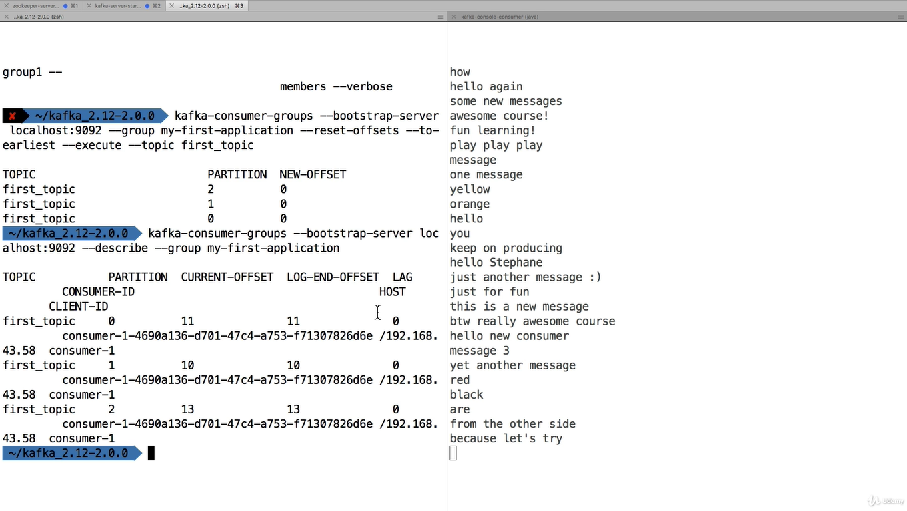

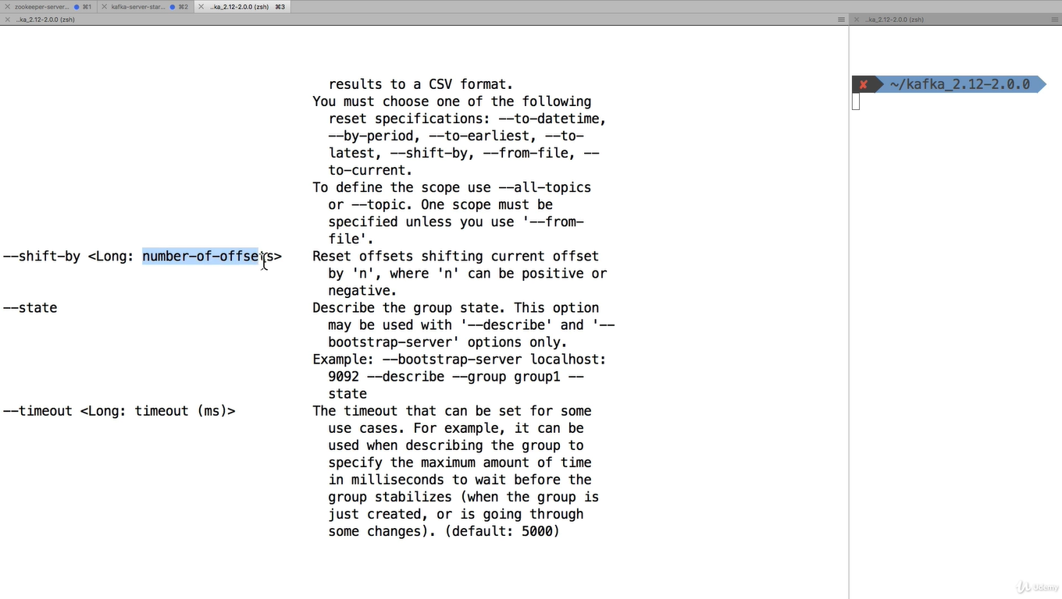

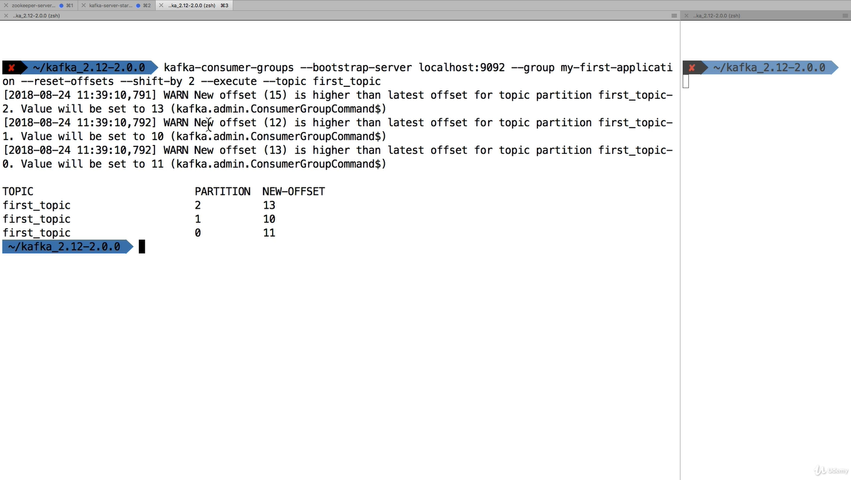

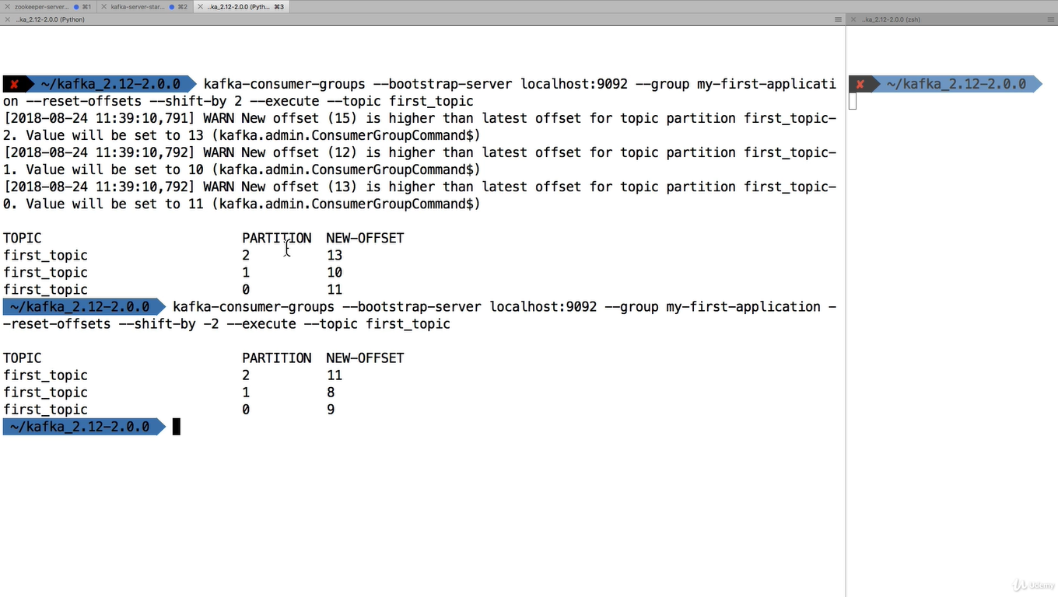

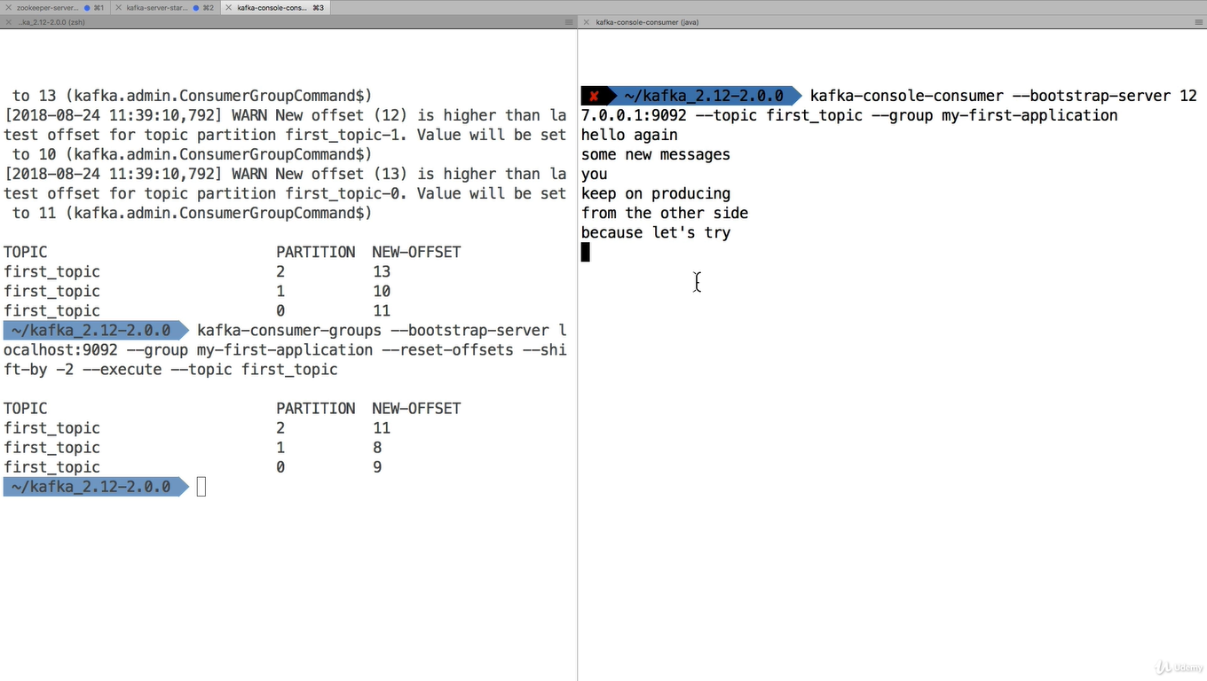

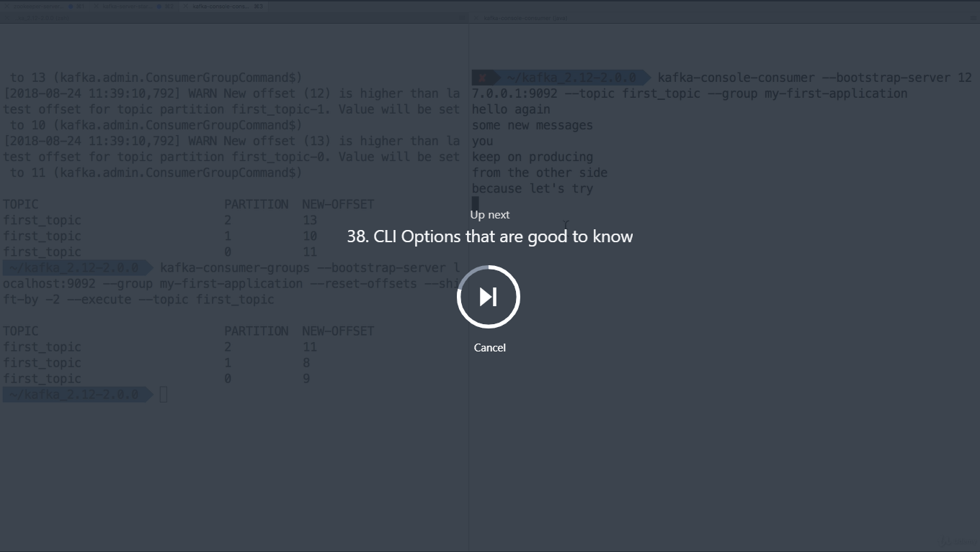

**The CLI has many options, but here are the other that are most commonly used:**

Producer with keys

1. kafka-console-producer --broker-list 127.0.0.1:9092 --topic first_topic --property parse.key=true --property key.separator=,
2. > key,value
3. > another key,another value

Consumer with keys

1. kafka-console-consumer --bootstrap-server 127.0.0.1:9092 --topic first_topic --from-beginning --property print.key=true --property key.separator=,

#### **Conduktor - Kafka GUI**

Kafka does not come bundled with a UI, but **I have created a software name Conduktor** to help you use Kafka visually.

You can download Conduktor here: <https://www.conduktor.io/>

Conduktor allows you to perform all the administrative tasks on Kafka (such as creating topics, partitions, etc), as well as produce and consume, all from within a desktop application that should work on Windows, Mac, and Linux.

**Please look these two pages in cases you're having issues:**

* Documentation: <https://www.conduktor.io/docs>
* The FAQ for installation issues (at the bottom of the page): <https://www.conduktor.io/download>

Finally, **follow**[**@GetConduktor**](https://twitter.com/getconduktor?lang=en)**on Twitter** to get the latest updates!

Here are some screenshots from the software:

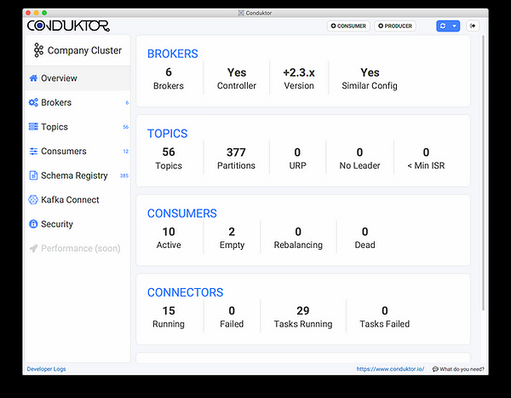

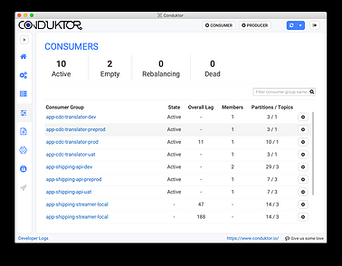

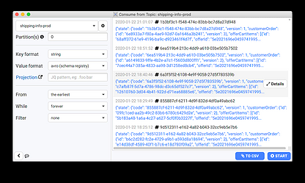

**Overall in this course, we perform all the actions without any UI, which is good for learning how to properly use the CLI**

Fullscreen

Go to Previous lecture

38. CLI Options that are good to

KafkaCat as a replacement for Kafka CLI

**KafkaCat (**[**https://github.com/edenhill/kafkacat**](https://github.com/edenhill/kafkacat)**) is an open-source alternative to using the Kafka CLI, created by Magnus Edenhill.**

While KafkaCat is not used in this course, if you have any interest in trying it out, I recommend reading: <https://medium.com/@coderunner/debugging-with-kafkacat-df7851d21968>

**Happy learning!**

